Learning Objective
We are learning how to write sentences about elephant seals in both the active and the passive voice.

Challenge 1

Highlight (using the colour-coded key) the subject (the agent of the action) and the object (the receiver of the action) for each of the following sentences:

- The grumpy elephant seal swiped the penguin with his flipper.
- The king penguin chicks were attacked by the enormous skua birds.
- The penguins’ nesting site was protected by the conservation group.
- The mother penguin fed her chick a mouthful of fish.
- In the nineteenth century, hunters killed southern elephant seals to extract oil from their blubber.
Key: Red = subject Green = object
Challenge 2
Rewrite the following active-voice sentences in the passive voice so that the agent of the action (bold) moves to the end of the sentence and the object (underlined) moves to the front (and becomes the subject of the sentence).
- During its hour-long dive, the elephant seal caught several squids.
e.g. During its hour-long dive, several squids were caught by the elephant seal.
- The sleek leopard seal bit the stray elephant seal pup.
- The battle-scarred seal defended his territory to the bitter end.
- The bold king penguin pecked the snoozing elephant seal.
- The aggressive bull seal bit the smaller male repeatedly in its chest area.

Challenge 3
Write your own script for Sir David Attenborough to accompany the elephant seal and king penguin clip that we watched at the beginning of the lesson. See if you can do this as a slow write, following the instructions below:
Sentence 1: Your sentence must be in the active voice.
Sentence 2: Your sentence must include a simile.
Sentence 3: Your sentence must be written in the passive voice.
Sentence 4: Your sentence must include a relative clause.
Sentence 5: Your sentence must include at least 2 words from the Word Wall.

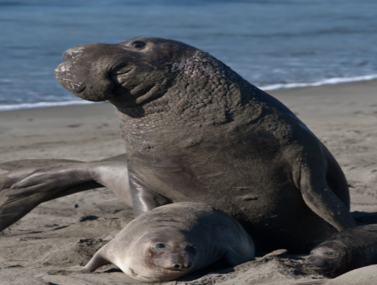
Word Wall
elephant seal
rival

barrier

slapped

sleeping giant

king penguin

blubbery beach master

waddled

crossfire

elephantine snout

