Learning Objective
We are learning how to write sentences about giraffe-necked weevils, using brackets, commas and dashes to indicate parenthesis.

Challenge 1
Read each sentence and place the parenthesis (additional piece of information) inside either a pair of brackets, dashes or commas.
- The miniature warriors with their giraffe-like necks battled for over an hour on the leaf.
- The cameraman a specialist insect photographer trudged through the soggy cloud forest.
- Giraffe-necked weevils like so many of Madagascar’s unique creatures are threatened by habitat loss.
- The leaf nest having taken almost an hour to make finally fell to the forest floor.
- The tiny yellow weevil larva began to feed on the leaf that had just been its nest.
- The female whose neck was much shorter than those of the battling males refereed the fight.
- The bright red wing cases which served as a danger warning to predators housed the beetle’s delicate wings.
Challenge 2
Rewrite each of the following sentences by adding a parenthesis after the word that has been highlighted in bold. Try to use the full range of parenthesis punctuation marks: brackets, dashes and commas.
- The aggressive weevil lowered its neck and charged at his opponent.
- The giraffe-necked weevil was nearing the end of its short life.
- The female wanted the male with the longest neck to win.
- Moments after falling to the forest floor, the leaf nest was eaten.
- In the air, the weevil looked like a helicopter out of control.

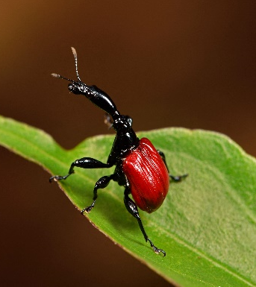
constructed
veins
creased
crane-like
parasites
curled
refereed
folded
guarded
rainforest
Madagascar
giraffe-necked weevil
Word Wall
Challenge 3
You are an entomologist (someone who studies insects). You have been asked to
write an article in the Bug Times about the recent discovery in Madagascar of a brand-new species – the giraffe-necked weevil. Try to include words from the Word Wall and at least three sentences that use parenthesis.

