Learning Objective
We are learning how to use a colon to introduce a list.

Challenge 1
Correct the following sentences by inserting the necessary punctuation marks.

- There are many areas of the world where locusts can be found Africa the Middle East and Asia.
- In Africa, desert locusts are eaten by a number of different predators spiders lizards birds wasps and even humans.
- The lifespan of a locust includes several different stages egg, nymph and adult.
- There are a number of African countries where swarms of locusts regularly wreak havoc Kenya Ethiopia Uganda and Somalia.
- Most of the time locusts exist in a ‘grasshopper phase’ and have the following features they are solitary insects they are green and they are relatively small in size.

Challenge 2
Rewrite each of the sentences below so that a colon introduces the list. Remember – your introductory clause must be able to stand alone as a sentence. Furthermore, when rewriting the sentences, remove the unnecessary ‘ands’ and replace them with the correct punctuation marks.

- The three main body parts of a locust are its head and its thorax and its abdomen.
- Maize and millet and sorghum and wheat are some of the cereal crops that locusts devour in Africa.
- Locusts look very similar to crickets and grasshoppers and cicadas.
- Farmers will try to scare away locusts by burning tyres and making loud noises by beating drums and spraying their crops with chemicals.
- When being prepared for human consumption, locusts can be dried and smoked and fried.
- The antennae on a locust’s head are used for sensing touch and for tasting and for smelling.

Challenge 3
You have been asked to
write an article for a wildlife magazine that explains why locusts are both fascinating and deeply destructive insects. Your article should include some of the words from the Word Wall and at least two sentences that use a colon to introduce a list.

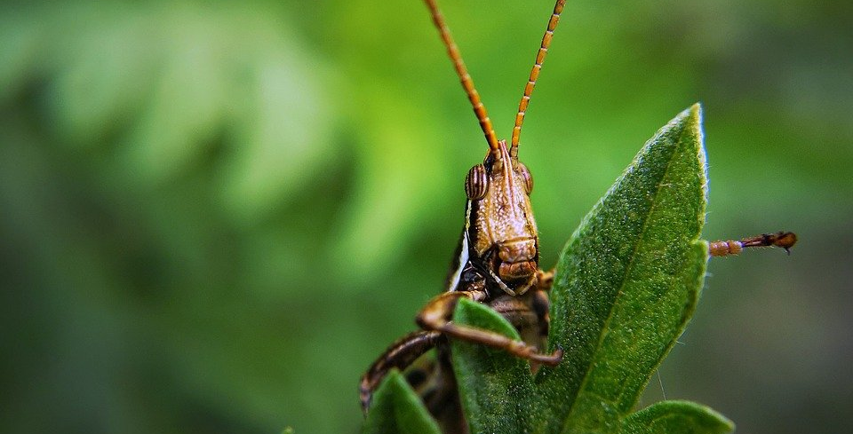
Word Wall
newly sprouting grass
Kenya, Ethiopia, Uganda, Somalia
pesticide
winged adult
plague
voracious appetite
cricket, grasshopper, cicada
solitary creature
swarm
transformed
locust
unstoppable force
conditions

