Learning Objective
We are learning how to link ideas using a range of cohesive devices.
Text cohesion relates to how well a piece of writing holds together, with phrases, clauses, sentences and paragraphs threaded together in a way that makes the text easy for the reader to follow and understand.

Challenge 1
Using words from the four boxes below, complete the information text about the melting of the Arctic sea ice. The words will help make it more cohesive by linking phrases, clauses, sentences and paragraphs.
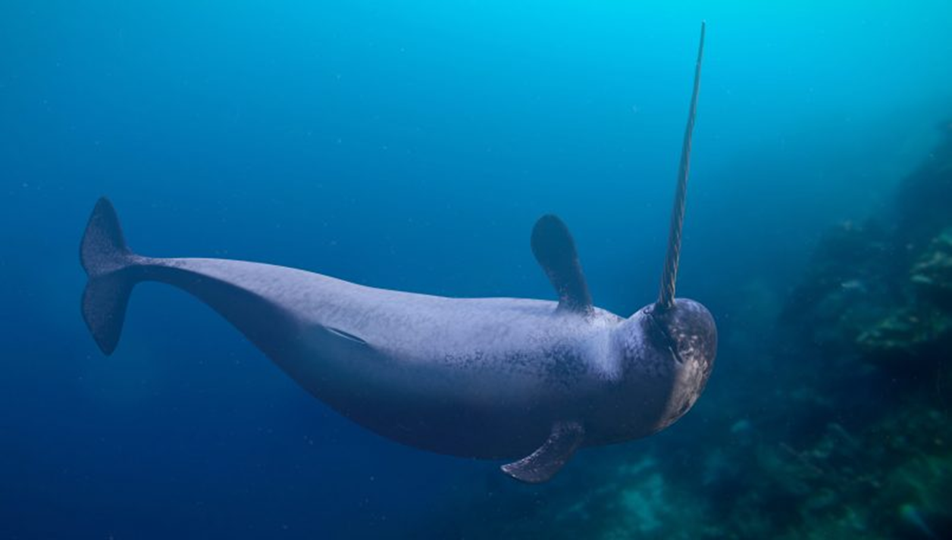
Synonyms & ‘other’ words

Conjunctive adverbials

Conjunctions

Pronouns

For example,
Despite,
because
it
their
creatures
species
Nevertheless,
However,
when
even
them
who
living organisms
Furthermore,
before
they

The shrinking of Arctic Sea Ice
During the winter, the top layer of the ocean near the North Pole freezes solid. Every summer, some of this ice melts, but not all of ______ . Some of the ice is so thick ______ stays frozen all the time, ________ throughout the summer. ____________ , since 1979, when Earth-observing satellites began watching, the ice remaining at the end of summer has been getting smaller and smaller.
_________ there’s less sea ice, animals that depend on it for survival must adapt or perish. Loss of ice and melting permafrost spells trouble for polar bears, walruses, Arctic foxes, snowy owls, reindeer, and many other _________ such as narwhals. As _________ are affected, so too are the other ________ that depend on them. _____________ , due to the shrinking of Arctic sea ice, wildlife and people are coming into more frequent contact. ______ can create conflict. __________ , polar bears (looking for refuge as _________ sea ice habitat disappears) sometimes end up wandering into Arctic communities. This often ends badly for both the polar bears and the people _______ live there.

_____________the problems outlined above, something can be done to prevent the Artic sea ice from disappearing. Reducing the amounts of greenhouse gasses (such as carbon dioxide) that are released into the atmosphere is our best chance of securing a safer future for the wildlife of the Arctic ________ prevent even more damaging consequences than we’ve already seen.
Challenge 2
The Arctic could be ice-free in the summer by 2040. It is everyone’s responsibility to think of ways that they can reduce their carbon footprints by living in a more environmentally sustainable way. Extend the final paragraph by writing about ways of achieving this. Try to maintain great text cohesion by thinking about the cohesive devices mentioned throughout the lesson.

