Learning Objective
We are learning how to write sentences about tigers in both the active and the passive voice.

Challenge 1
Decide if the following sentences are in the active or passive voice.
- The tiger’s forest was destroyed for firewood. (active/passive)
- The trees were urinated on by the territorial tiger. (active/passive)
- The poacher killed the tiger for its body parts. (active/passive)
- The wild pig was being stalked by the striped carnivore. (active/passive)
- The stealthy tiger pounced on the raucous peacock. (active/passive)
- The man-eating tiger had been shot by a frightened villager. (active/passive)
- In silence, the nocturnal hunter watched the buffalo. (active/passive)

Challenge 2
Rewrite the following active-voice sentences in the passive voice so that the agent of the action (bold) moves to the end of the sentence and the object (underlined) moves to the front (and becomes the subject of the sentence).
- The tiger killed the antelope with a bite to its neck.
The antelope was killed by the tiger with a bite to its neck.
- The tigress attacked the peacock from behind.
- The scientists tracked and monitored the small tiger population.
- The scientist discovered the 30,000-year-old fossilized remains of a sabre-toothed tiger.
- The park ranger arrested the poacher, whose bullet had fatally wounded the tiger.

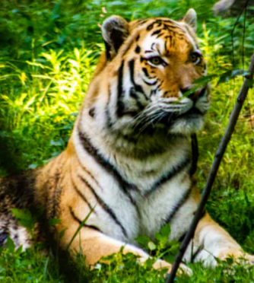
Challenge 3
Write your own script for Sir David Attenborough to accompany the tiger and peacock clip that we watched at the beginning of the lesson. See if you can do this as a slow write, following the instructions below:
Sentence 1: Your sentence must be written in the active voice.
Sentence 2: Your sentence must include a simile.
Sentence 3: Your sentence must be written in the passive voice.
Sentence 4: Your sentence must include a relative clause.
Sentence 5: Your sentence must include at least two words from the Word Wall.

Bengal tigress
Word Wall
paraded
ambush predator
iridescent tail feathers
crouched
pounced
startled
amorous peacock
striped assassin

