Learning Objective
We are learning how to write simple sentences.
A simple sentence contains a subject and a verb and expresses a complete thought.

Challenge 1
Put a full-stop in the box if you think any of the following are simple sentences.

1) The hare’s fur coat was extremely thick
2) The bitter wind
3) The hares moved as a group
4) The Arctic wolf was closing in
5) Its short ears
6) The hare bounded across the frozen wilderness
7) Large feet on the snow

Challenge 2
Oh dear! The following should all read as easily understood simple sentences. Can you change the word order and create a simple sentence in the space provided?

1) The hare Arctic had a white coat beautiful.
______________________________________________________________________
2) Ravenous the wolf the frightened hare chased.
______________________________________________________________________
3) Different colour fur the Arctic hare’s was a.
______________________________________________________________________
4) The huddled warmth together Arctic hares for.
Challenge 3
Using some of the descriptive words from the Word Wall, write your own simple sentences about an Arctic hare from what you have learnt about them in the lesson. Check that each sentence has a subject, a verb and expresses a complete thought.

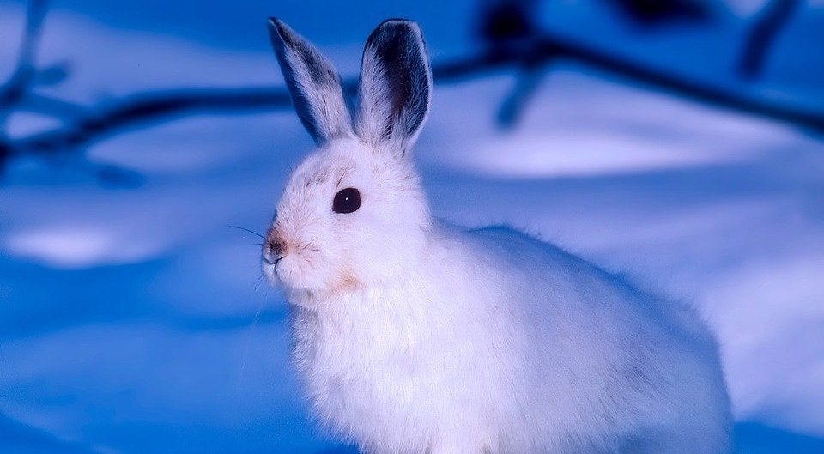
Word Wall
snow-white
camouflage
Arctic hares
nervous
wolves
defeated
escaped
ravenous
chased
powdery snow

