Learning Objective
We are learning how to demarcate sentences with capital letters, full stops, question marks and exclamation marks.

Challenge 1
Match these sentences to their sentence type using what you know about punctuation.

What an enormous, hefty mammal! |  | Question
Where do most bison live in the world? |  | Statement
Bison are massive, shaggy beasts with scraggly beards and curved horns. |  | Command
Move away from the mighty bison. |  | Exclamation

Challenge 2
Using this picture as your stimulus, write a statement, question, command and exclamation.
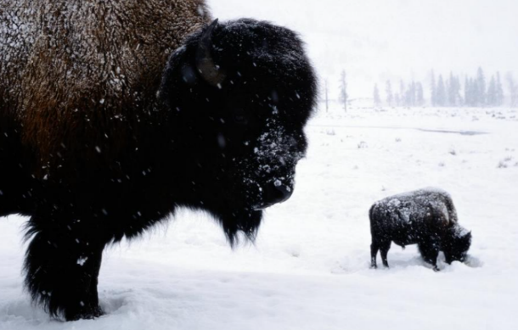
Question – ____________________
_________________________
Statement –___________________
_________________________
Command –____________________
_________________________
Remember to check you have used the correct end punctuation and a capital letter to start!
Exclamation -___________________
_________________________

Challenge 3
You have been asked to rewrite the narration for the main film clip. You will need to use the full range of sentence types to keep your audience entertained and build up suspense as the bison begin to battle. Try to include some of the descriptive words from the Word Wall.
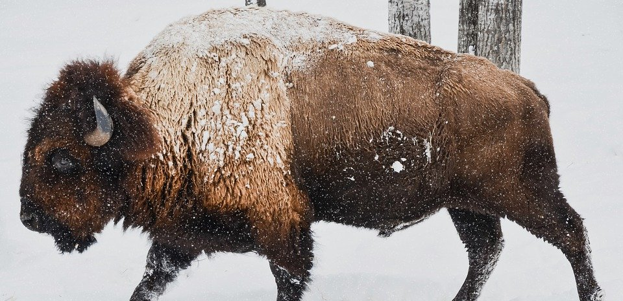
head-butted
distinctive hump
muscular body
upward-curving horns
scraggly beard
clashed
bison
Yellowstone National Park
dust cloud
Word Wall

