Learning Objective
We are learning how to write simple sentences.
A simple sentence contains a subject and a verb and expresses a complete thought.

Challenge 1
Put a full-stop in the box if you think any of the following are simple sentences.
1) Nemo was a daring clownfish
2) The heavy coconut shell
3) At the bottom of the ocean
4) Pushing with all their might
5) Incredibly, the male clownfish turned into a female
6) The warm tropical waters
7) The anemone provided protection

Challenge 2
Oh dear! The following should all read as easily understood simple sentences. Can you change the word order and create a simple sentence in the space provided?

1) The shell coconut finally started move to.
______________________________________________________________________
2) Female the clownfish laid five hundred eggs over.
______________________________________________________________________
3) The clownfish pair of saddleback together worked.
______________________________________________________________________
4) On the coconut seabed the shell around spun.

Challenge 3
Using some of the descriptive words from the Word Wall, write your own simple sentences about the clownfish featured in the main film clip. Check that each sentence has a subject, a verb and expresses a complete thought.

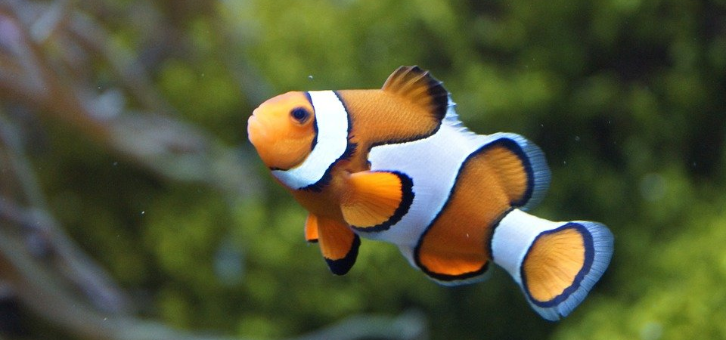
Word Wall
saddleback clownfish
stripy
coconut husk
determined
carpet anemone
stinging tentacles
rolled
teamwork
nudged
tucked

