Learning Objective
We are learning how to use the apostrophe to indicate possession.

Challenge 1
Add the apostrophes for possession to the correct places in the sentences below.
(Hint - there is only one gentoo penguin in possession of something.)

- The gentoo penguins beak stands out with its bright red-orange colouring.
- The gentoo penguins predators include sea lions and leopard seals.
- A gentoo penguins mother will feed her chicks with food stored inside her beak.
- Surprisingly, a gentoo penguins habitat is often ice free!
- Amazingly, a gentoo penguins streamlined body and strong flippers allow it to swim faster than any other diving bird.

Challenge 2
Finish these sentences in your own words, paying attention to the position of the apostrophe after the singular noun.

- A gentoo penguin’s flippers ____________________________________________.

- A gentoo penguin chick’s wings __________________________________________.

- The lobster krill’s shell _______________________________________________.

- The mother gento penguin’s eggs ________________________________________.

- A gentoo penguin’s webbed feet ________________________________________.

Challenge 3
Using some of the words from the Word Wall, write a short paragraph that describes a gentoo penguin hunting for food and feeding its chicks.
See if you can include possessive apostrophes to describe what belongs to the gentoo penguin. Think carefully about the position of the apostrophe- especially if you decide to mention more than one penguin or chick owning something e.g. ‘The chicks’ beaks were wide open.’

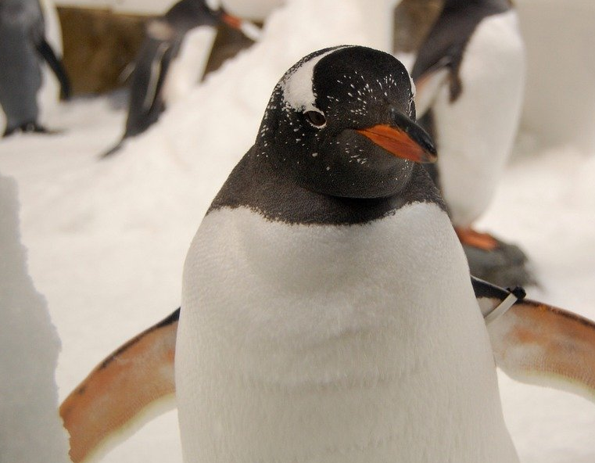
Word Wall
paddle-shaped flippers
torpedo-like
chicks
waddled
white-feathered cap
peach-coloured webbed feet
lobster krill
Falkland Islands
gentoo penguin’s (one)
colony
gentoo penguins’ (more than one)

