Learning Objective
We can use a fronted adverbial to show when, where or how something happened.

Challenge 1
Using link lines, match each fronted adverbial to the correct main clause.
With its spade-like feet,
Sadly,

In the coastal areas of South Africa,

As the sun began to set,

Camouflaged,

Patiently,

the marshmallow frog waited for the termites to crawl across its oddly-shaped body.
the marshmallow frog dug its sandy burrow.
its yellow-brown colour matches its sandy environment.
the ocean fog keeps the sand damp in this otherwise dry region.
the stumpy marshmallow frog clambered over the sand dunes.
the marshmallow frog is an endangered species because tourism and mining threaten its habitat.

Challenge 2

Rewrite the sentences below so that the adverbial phrase is at the front, separated from the rest of the sentence by a comma.
e.g. The marshmallow frog left strange-looking footprints on the sand dune.
On the sand dune, the marshmallow frog left strange-looking footprints.

1) The curious marshmallow frog laid her eggs in the sandy burrow.
____________________________________________________________________

2) He waddled across the barren landscape as the stars twinkled.
______________________________________________________________________

3) The marshmallow frog tried to eat the termite with a flick of his long tongue.
______________________________________________________________________

4) He emerged from his burrow as the fog was beginning to lift.
______________________________________________________________________

6) The oddly-shaped frog squeaked over and over again.
______________________________________________________________________
Challenge 3
You are applying for a job as David Attenborough’s assistant. He would like you to write a new narration for the main film clip, ‘The Marshmallow Frog’. To really impress him, use lots of fronted adverbials in your writing. Use the Word Wall to help you.

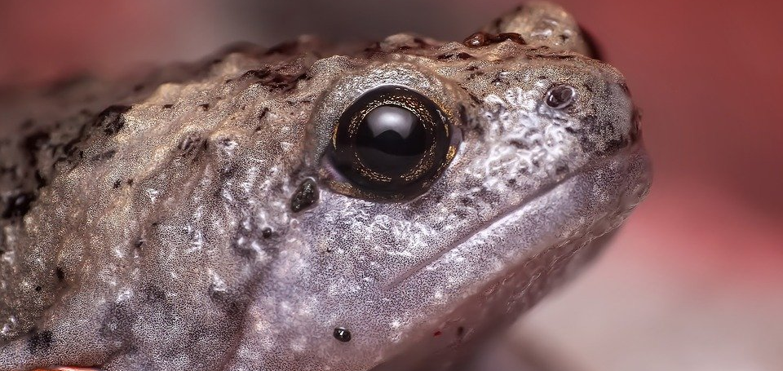
Word Wall

marshmallow frog
Namib Desert
stubby body
towering sand dune
sticky tongue
munched
bulging eyes
termites
amphibian
waddled

