Learning Objective
We are learning how to use inverted commas.

Challenge 1
Someone has forgotten to put the inverted commas (speech marks) around the spoken words in the sentences below. Can you put them in the right places?

1) That’s one supersized egg! said the presenter excitedly.
2) Olly the ostrich boomed, Be gone you pesky hyena!
3) I’m glad I can’t fly said Olly the ostrich. I’m afraid of heights!
4) Watch out for those legs, warned the leader of the hyena clan. They can kill.
5) Mum’s wings are like an umbrella, shading us from the sun, said the eldest chick .
6) The zebras and antelopes are on the move, announced Olly with two large eyes fixed on the horizon. It’s time to move.

Challenge 2
Use your knowledge of inverted commas (speech marks) to write what this hyena and ostrich are saying to each other in your Literacy book. Don’t forget to use a reporting clause to tell your reader who is speaking and how they might be feeling.

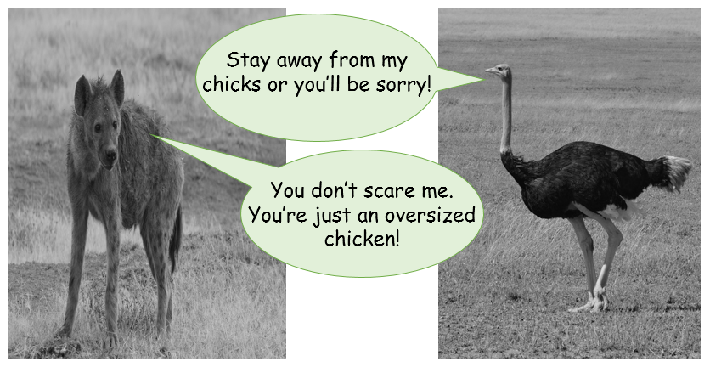

Challenge 3
Use your knowledge of inverted commas (speech marks) to continue the conversation between the hyena and the ostrich (above). Will you introduce a third character? Another member of this hyena’s clan perhaps? Don’t forget to use reporting clauses to tell your reader who is speaking and how they might be feeling as well as describing any actions that the animals might be doing.

