Learning Objective
We are learning how to use capital letters in our writing.

Challenge 1
Look closely where capital letters have been used in the following sentences. Shade the word which includes a capital letter the right colour according to its purpose (green, blue or red).

Purpose | Sentence
Beginning of a sentence | The Pallas’s cat has thick, stripy fur.  To help protect their eyes during dust storms and strong, cold winds, the Pallas’s cat has a third eyelid!  The cats live in dry, cold conditions in mountainous regions like the Himalayas.  My birthday is in January, and although the Pallas’s cats look cute, I wouldn’t want one as a pet.  These wildcats hunt small mammals. I’ve seen them do this on the TV.  Potter Park Zoo is home to one Pallas’s cat, known as “Olaf.”
Proper noun
(This includes names of places, people, animals and months.)

The pronoun ‘I’

Challenge 2
Oh no! The computer has gone crazy and given all the words in these sentences capital letters! Rewrite the paragraph using capital letters correctly.

Pallas’s Cats Are Not Very Fast Runners So They Use Ambush Skills To Catch Their Prey. This Also Means That When They Are Threatened Or Scared, They Freeze And Crouch Close To The Ground. Life Is Quite Tough For The Fluffy Felines As They Survive High Up In Mountainous Habitats in Central Asia And They Can Live Between 3 And 6 Years In The Wild.
Challenge 3
Write your own sentences about the Pallas’s cat using some of the words from the Word Wall, but deliberately miss out the capital letters. Share your work with a partner to see if they can spot all the missing capital letters.

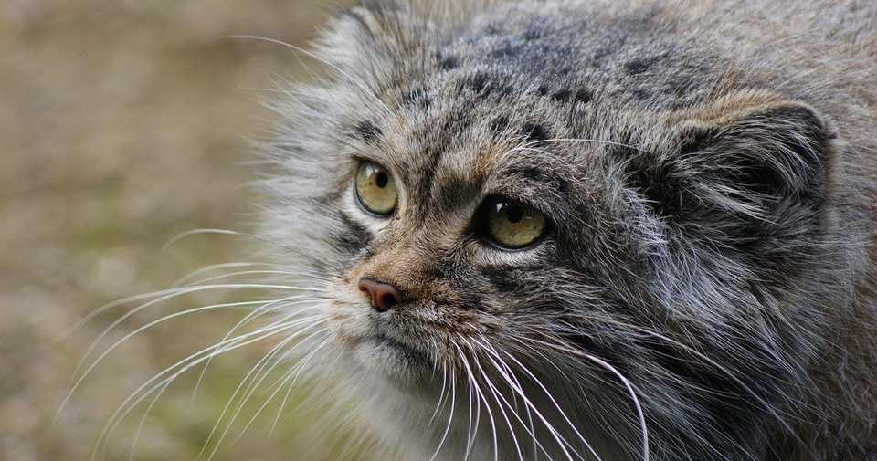
Word Wall
Pallas’s cat
Mongolia
pounced
stalked
playful kittens
hide-and-seek
Himalayas
silver vole
thick fur
rounded ears

