Learning Objective
We are learning how to write sentences that use prepositions to show a relationship between things typically in terms of place, direction, time and cause.

Challenge 1
Complete the sentences by choosing an appropriate preposition from the list below:
with
on

towards
under
upon
away

- The sea otters float _______ the surface of the sea.
- The sea otters saw the wave moving __________ them.
- A sea otter pup often lies __________ its mother’s chest.
- Sea otters are hunted by orcas and sea lions, so if they see one of these animals they will try to move ______ from it.
- Sea otters can stay still in a wave ______ help from kelp.
- Sea otters are excellent swimmers and can swim on and ________ water.

Challenge 2
Use lines to join up the two parts of the sentences that have been split up and mixed up. Then, underline the words that are prepositions in each sentence. Look carefully as there may be more than one preposition in some sentences!

It is almost impossible for a sea otter pup to drown |  | to prevent itself from being dragged away by large waves.
When sea otters sense large waves coming towards them, |  | sea otters can be found floating in large groups on the surface of the sea.
Sea otter pups lie on their mothers’ |  | they seek refuge in kelp forests.
A sea otter will twist kelp around its body |  | chests.
As they are social creatures, |  | because of the amount of air trapped in its fur.

Challenge 3
Using some of the words from the Word Wall, write your own scintillating sentences to describe the sea otters you met in the film clip. Be sure to copy the spellings of Word Wall words ever-so-carefully!

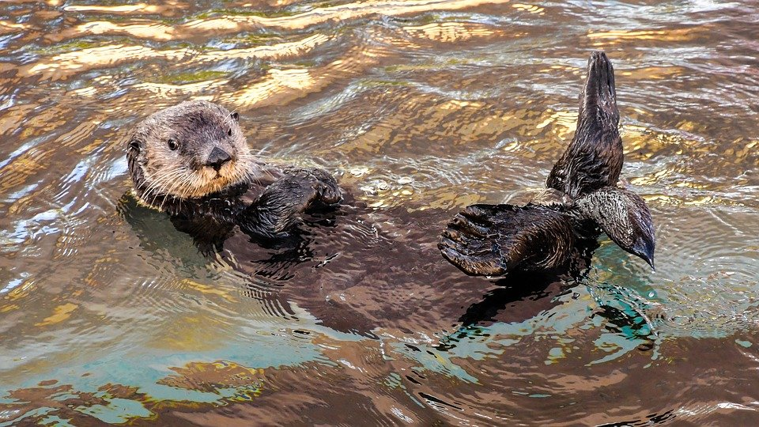
Word Wall
(direction) towards, through, between
thick fur
kelp
lounging
pups
Alaska
glacier
sea otter
(time) before, after, during, at
enormous wave
(place) below, above, among, beside

