**Learning Objective**

We are learning how to use prepositions in sentences to show time, place and cause.

**Challenge 1**

**Complete the following sentences by choosing the most appropriate preposition from the list below:**

**in**

**within**

**along**

**on**

**into**

**throughout**

1. **_____** a daily basis, sulphur-crested cockatoos need exercise because they are highly active and lively birds.
2. Sulphur-crested cockatoos can be found _______ Australia’s north-central coast and _____________ the eastern third of the continent and on the island of New Guinea.
3. These cockatoos always need to be ______ flying distance of water but otherwise inhabit a range of habitats including forests, open woodlands, savannas and farms.
4. They tend to remain ____ their favourite nesting sites for decades even if the availability of food means they need to fly further away.
5. These intelligent birds keep watch for danger, often flying high ____ the air and letting out a loud screech in warning to their flock.

**Challenge 2**

**Complete the following paragraph with your own suitable prepositions of time, place and direction.**

The word ‘sulphur’ has been used to describe the crest ______their head. Its yellow colouring is similar to the colour of crystallised sulphur. They have zygodactyl feet. This allows them to grasp objects with one foot _________ standing on the other. ____ the wild, these birds have a varied diet and are known to feast on seeds, fruits, nuts, flowers, leaf buds, roots, insects and berries. _________ the day, you may spot them hanging out in large trees looking for food or simply doing some DIY to their home.

**Challenge 3**

**Using some of the prepositions and descriptive words from the Word Wall, write your own scintillating sentences about the antics of a mischievous sulphur-crested cockatoo.**

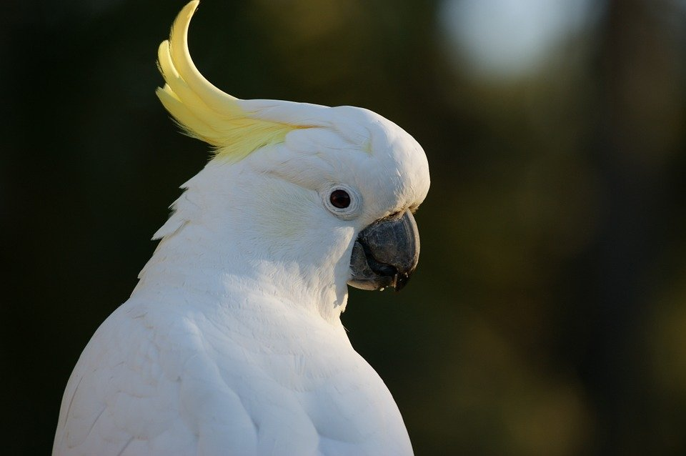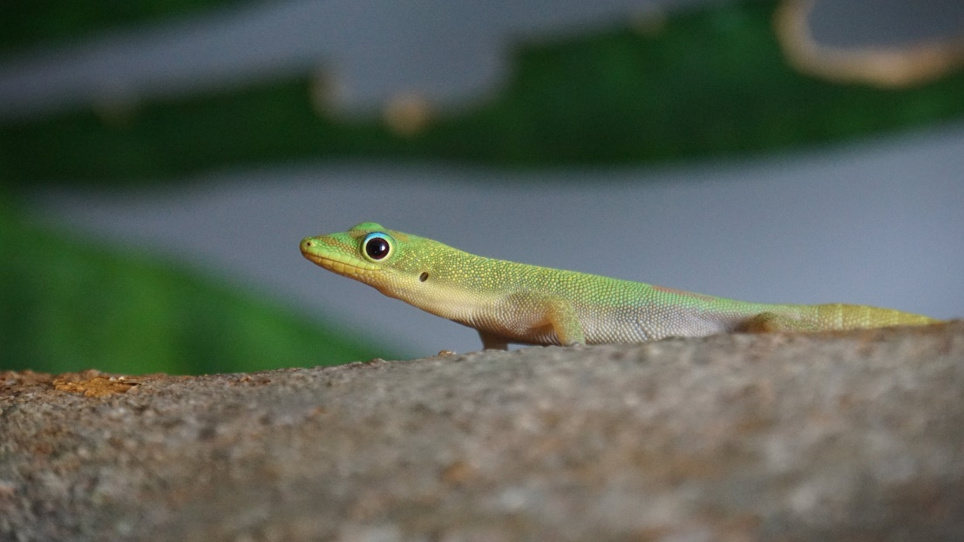

**Word Wall**

hooligan

fanned

Sydney

destroyed

sulphur-coloured crest

snow white feathers

(direction) towards, through, between

hooked beak

(time) before, after, during, at

vandal

(place) below, above, among, beside, beneath