Learning Objective
We are learning how to proofread for spelling, punctuation and grammar errors.

Challenge 2
Use the CUPS checklist to find and fix the mistake in each of the following sentences. Hint: The letters at the end of each sentence (inside the brackets) will tell you which mistakes to look out for.

C= capital letters U = understanding (missing words) P= punctuation S=spelling

1) Tapirs, like mandi, can be found in the amazon rainforest. (C)
2) Tapirs can live for 25 – 30 in the wild. (U)
3) Tapirs are herbivores that eat leafs and froot. (S)
4) rodolpho was very pleased with mandi as she showed many signs that she would cope when released into the wild. (C)

5) The baby tapir s brown fur with white stripes helped it to blend into the forest floor (P)
6) The tapir’s splayed tows stoped it from sinking into the mud. (S)

Challenge 2
Edit the sentence below using the CUPS checklist.

1) Tapirs have existed on earth for Millions of and scientists believe thay have not changed much in all this time
2) Tapirs an endangered species becos they are hunted. And their Habitats are being destroyed.
3) when they feel feel nervous, tapirs head for warter. to feel safe.
4) tapirs have been around longer many other mamals on the planet today
Challenge 3
Using some of the descriptive words from the Word Wall, write a short paragraph about Mandi the tapir. Proofread your sentences with the CUPS checklist and then swap your writing with someone else. Have they done a good job of proofreading? Is there anything else that needs correcting?

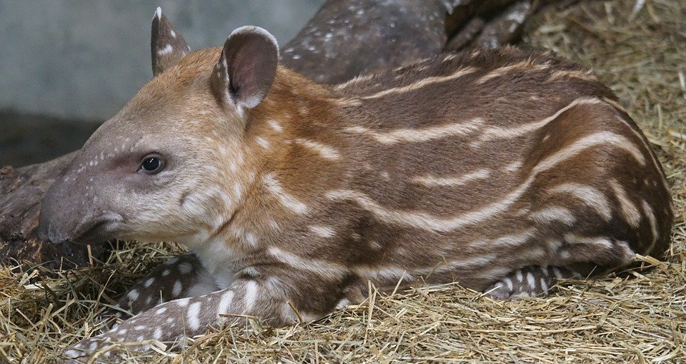
Word Wall
undergrowth
snuffling snout
tapir
submerged
orphan
Amazon rainforest
trotted
detected
herbivore
shy

