Learning Objective
We are learning how to write simple sentences.
A simple sentence contains a subject and a verb and expresses a complete thought.

Challenge 1
Complete the following simple sentences by selecting an appropriate verb from the list below:
emerge
are
eat
crossed
take
grow
live

- Toads ______________ worms, slugs and other small insects
- Female toads __________ later than male toads.
- Toads __________ in dark, damp places such as under logs.
- Their babies (tadpoles) ___________ about ten days to hatch.
- Toads ____________ a type of amphibian.
- Female toads __________ larger than males.
- The warty toads ____________ the dangerous road safely.

Challenge 2
Re-arrange each word list below to make simple sentence. Don’t forget to start each sentence with a capital letter and use the correct end punctuation mark.

- than larger frogs are toads
- 1,500 female around eggs lay toads
- the toadlets pond ready leave to were the
- road the frogs needed cross to the deadly
- threatened puff toads up when they are
Challenge 3
Using some of the descriptive words from the Word Wall, write your own simple sentences about a toad making its perilous journey to a breeding lake. Check that each sentence has a subject, a verb and expresses a complete thought.

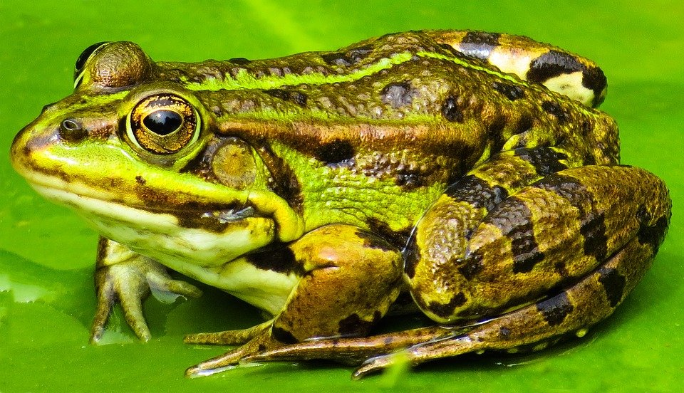
Word Wall
wide-mouthed
breeding lake
common toad
bulging eyes
warty
hibernating
emerged
dangerous road
string of eggs
mate

