
Learning Objective
We are learning how to write effective similes about blacktip sharks.

Challenge 1
Read the diver’s recount of a blacktip shark sighting, and highlight the similes.

“I spotted the blacktip whilst diving in a shallow reef. It shot past me like a speeding bullet. I think it was afraid of the bubbles my diving gear was creating. Fortunately, I didn’t have to wait too long for it to return. As I looked up, there it was, gliding gracefully through the water like a ghost haunting the darkened corridors of an old schoolhouse. Although blacktips rarely attack humans, I knew I must remain calm and avoid any sudden movements. With its teeth as sharp as razor blades, I didn’t want to take any chances.”
(Now copy your favourite simile and explain why you chose it.)

Challenge 2
Copy the sentences and complete each one with a simile.

1) The blacktip was shaped like …
2) The blacktip’s formidable teeth were as sharp as …
3) The ravenous predator swam as quickly as …
4) Like ____________, the remarkable blacktips worked together.
5) The formidable blacktips attacked the bait ball like …
6) The underwater hunters herded the fish like …
7) Following the feeding frenzy, scales littered the ocean like …
8) As _____________, the intelligent blacktips vanished into the deep.

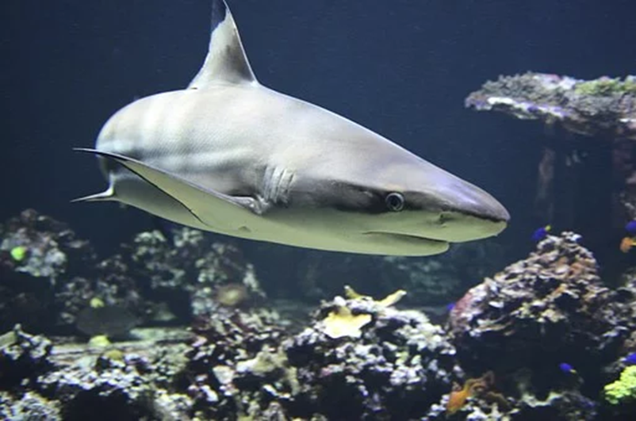
Challenge 3
Continue the shark poem below using your knowledge of blacktips (and sharks in general). Try to imitate the structure used: in the first line use a simile (see italic text) and in the second line develop the imagery captured in the simile (see bold text).

Shark
Eyes as black as coal
But there is no warmth burning within.
Teeth like a snaggle-toothed saw
Beware the grimace of death.

