Learning Objective
We are learning how to use the correct determiners ‘a’ and ‘an’ in our writing.
‘An’ – use this determiner before words that start with a vowel sound.
Vowels - a, e, i, o and u
‘A’ – use this determiner before words that don’t start with a vowel sound.

Challenge 1
With your teacher, read the following sentences and complete them by choosing the correct determiner ‘a’ or ‘an.’

1) The bonobo toasted ____________ marshmallow over the fire.
2) The bonobo found _____________ earthworm that was long and juicy.
3) After ____________ tiring day, the bonobo climbed into his nest.
4) Building their sleeping nest wasn’t ________ easy job for the bonobos.
5) Due to _____ loss of habitat, bonobos are a threatened species.
6) It was __________ honour to watch the bonobos at play.
7) Bonobos can be found in __________ area of Africa close to the Congo River.
Challenge 2
Read the following sentences and circle where you think ‘a’ or ‘an’ has been used incorrectly. The first one has been done for you.

1) The strong bonobo is dragging an branch behind him.
2) An baby bonobo begins life completely dependent on its mother.
3) After a hour passed, the bonobos starting grooming each other again.
4) The hungry bonobo popped a egg into his mouth.
5) A crocodile will eat a bonobo if given the chance.
6) A elephant startled the bonobo, who scrambled up an tree
7) Confusing the bonobo with an chimpanzee was a honest mistake.
Now compare your answers with a shoulder partner. Can you explain why you did/didn’t circle ’a’ or ‘an.’
Challenge 3
Using some of the descriptive words from the Word Wall, see if you can write 3 of your own sentences about bonobos that include the correct use of the determiners ‘a’ or ‘an.’
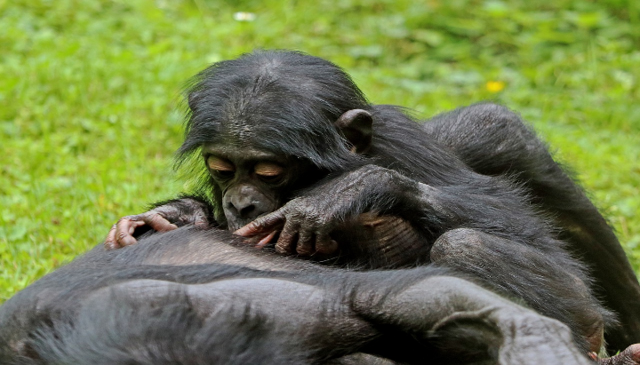
Word Wall
primate
human-like
intelligent
bonobo
an
a
fire
long black hair
marshmallow
flickering flame

