Learning Objective
We are learning how to write sentences that use prepositions to show a relationship between things typically in terms of place, direction and time.

Challenge 1
There are a number of prepositions in the paragraph below. Can you highlight them?

One of the reasons a dipper is called a dipper is because of the way it sits beside the river and bobs or dips its body. This special bird is unique because it can fly into the water and swim under the surface for up to thirty seconds. After they have laid eggs, the mother bird will sit on them and keep them warm for about two weeks. Once the eggs have hatched, both parents will search nearby in order to keep them well fed.

Can you copy the preposition that describes
1) where the dipper was bobbing in relation to the river? ____________
2) where the dipper was swimming in relation to the water? ____________
3) when the mother sat on her newly-laid eggs? ____________
4) where the parents were in relation to the chicks as they hunted for food? ____________

Challenge 2
Complete the sentences by choosing an appropriate preposition from the list below, you must use each word:
into
among
under
beside

above

- The dippers dive _______ the water to search for food.
- Dippers often sit __________ the river, bobbing their body and flicking their tail.
- They have an unusual technique of being able to walk _____ the water to catch their food.
- The dipper makes a sweet singing sound, which can often be heard _______ the noise of the river.
- You can spot a dipper in most areas of the UK where there are fast flowing rivers as they will be sitting _______ the rocks.
Challenge 3
Imagine you are a dipper. Using as many time, place and direction prepositions as you can from the Word Wall, describe your journey from the nest, through the waterfall, into the water and back in order to feed your chicks. Make it sound exciting and add as much detail as possible.

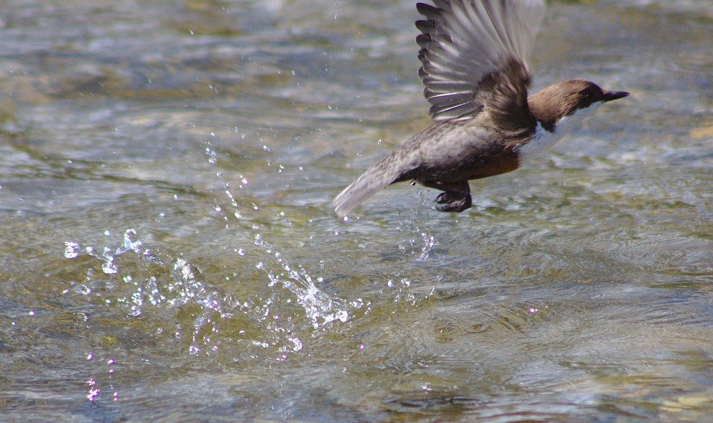
Word Wall

(direction) towards, through, between
chirping
waterproof
(time) before, after, during, at
(place) below, above, among, beside, beneath
bobbing
darted
preened
dived

