Learning Objective
We are learning to use commas in lists.

Challenge 1
Use your proofreading pen or pencil to add commas to the correct places in the following sentences:

1) The tiny frog fed on insects moths and spiders.
2) The rainforest habitat of the dwarf frog was hot sticky and brimming with life.
3) Frogs toads salamanders and newts are all types of amphibian.
4) Frogs that live in rainforests can be brilliant orange bright blue and dazzling red.
5) Cuba is a tropical island with stunning beaches rolling hills fabulous forests and mighty mountains.
Challenge 2
Take out the unnecessary ‘ands’ from these sentences and rewrite them as a list.

1) The dwarf frog was fingernail-sized and brightly coloured and poisonous.
________________________________________________________________________________________________

2) The presenter was surprised and excited and curious when he saw the tiny frog.
________________________________________________________________________________________________

3) Some bird species and toads and fish will eat Monti Iberia dwarf frogs if given a chance.

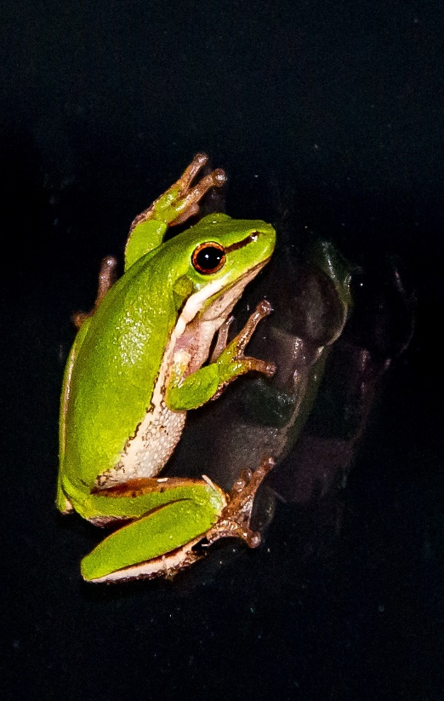
______________________________________________________________________

Challenge 3
You have been asked to write the narration for a nature programme that features a Monte Iberia dwarf frog exploring its rainforest home. Try to use some of the descriptive words from the Word Wall and include two list sentences that are correctly punctuated. You could start with the following sentence:
Deep in the rainforest, a fingernail-sized frog was exploring its leafy habitat.

Word Wall
rainforest
undergrowth
dwarf frog
fingernail-sized
amphibian
leapt
brightly coloured
poisonous
scrambled
long-legged

