Learning Objective
We are learning how to extend sentences using a wider range of conjunctions including and, but and or.

Challenge 1
In each of the extended sentences below, a coordinating conjunction is missing. Which of the following conjunctions will you write in the spaces provided?
but
or
and

1) The ants locked their legs together ______ created a living raft.
2) On the water, the ants could be eaten by fish ______ other predators.
3) Fire ants are amazing insects, ______ I wouldn’t want to be stung by one!
4) The queen was in grave danger, ______ fortunately the worker ants came to her rescue.
5) In a fire ant colony there are large worker ants _____ there are small worker ants.
6) The ant tried to escape the jaws of the Venus fly trap plant _____ there was no way out.
7) The queen could stay in the nest and risk drowning _____ she could leave with the others.

Challenge 2
Extend each of the following sentences from the coordinating conjunction.

1) The worker and soldier ants tried to save their queen, but ________________________
______________________________________________________________________
2) The ants must work together or ___________________________________________
______________________________________________________________________
3) The ant raft floated down the river and _____________________________________
______________________________________________________________________
4) The ant raft was almost safe, but___________________________________________

Challenge 3
Using some of the descriptive words from the Word Wall, write your own extended sentences about the fire ants featured in the main film clip. Your sentences must contain a coordinating conjunction (and, but, or).
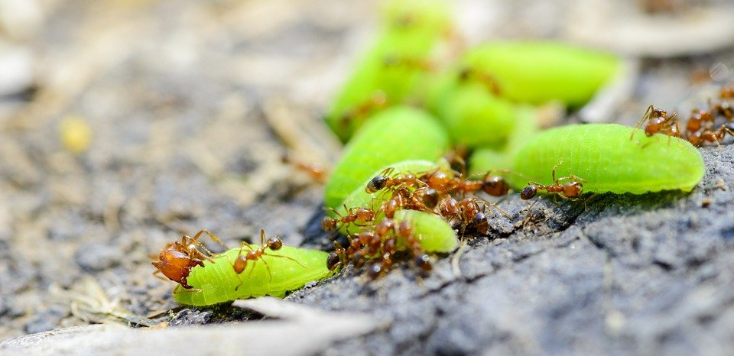
Word Wall
and, but, or
fire ants
colony
interlocked
precious
pancake-shaped
living raft
queen
teamwork
drifted
larvae

