Learning Objective
We are learning how to use capital letters in our writing.

Challenge 1
Identify which lower case letters need to be turned into capital letters and correct with your proofreading pen or pencil.

1) hedgehogs are famous for their prickly spines
2) one late sunday evening, i saw a hedgehog eating a slug.
3) with the help of thea, harvey the hedgehog made a speedy recovery.
4) they have featured hedgehogs many times on a programme called springwatch.
5) in the uk, hedgehog numbers have fallen by at least 30% since 2000.
6) several schools in bristol have made their school grounds hedgehog friendly.
Challenge 2
Rewrite each of the following sentences, using your knowledge of when capital letters need to be used.

- the hedgehog sniffed the air.
_________________________________________________________________
- i have decided to name the hedgehog that visits my garden horris.
_________________________________________________________________
- the hedgehog was frightened. it rolled into a tight ball.
_________________________________________________________________
- hedgehogs can be found in europe, asia, africa and new zealand.
_________________________________________________________________
- a blond hedgehog called henry lives on the island of alderney.
_________________________________________________________________
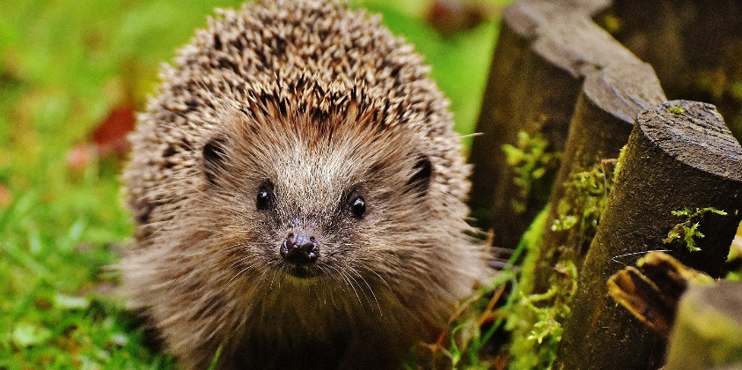
quill/spine
protection
defence
curled up
poor eyesight
hibernation
foraging
nocturnal
mammal
hedgehog
Word Wall
Challenge 3
Using some of the descriptive words from the Word Wall, write a short paragraph that describes an encounter with a hedgehog late one evening. Take extra care to make sure there are capital letters in all the correct places!

