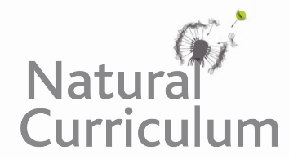
Learning Objective
We are learning how to use a thesaurus to find words that have a similar meaning when writing sentences about hyenas.

Challenge 1
With a friend/talk partner, use a thesaurus to replace each of the bracketed words with a suitable synonym. (If the word you find is unfamiliar to you, use a dictionary to make sure that you use the word correctly.)

The Spotted Hyena
Spotted hyenas are the largest of the three species of hyena (spotted, striped and brown) that live on our planet. Their jaws are (perfect) ____________for (crushing) __________ bones and are amongst the strongest in the entire animal kingdom. They have good hearing and excellent night vision.
Spotted hyenas are (skilful) ___________ hunters that rely on speed, (endurance) _____________ and teamwork to catch large prey such as wildebeest, antelope, zebras and young hippos. Clans often work together to (separate) _____________ from a herd an already weakened animal. As they (chase) _____________ their victim, they will take chunks out of it until it falls. Death usually comes swiftly thereafter, and the hyenas will often (squabble) ___________ over their kill.
Throughout Africa, spotted hyenas often come into (conflict) ____________ with lions when an animal has been (killed) _____________ . Although the lions usually dominate, despite being outnumbered, the hyenas will attempt to steal (scraps) ____________of meat and bone from the lions. In most cases, though, the hyenas will simply lie down and wait for the lions to become too hot or full and leave the (carcass) _____________ .
Spotted hyenas have few natural predators other than lions. Deaths usually occur when fights break out over food. Being twice their size and over three times their weight, a lion can kill a hyena with a single (stroke) ___________ of the paw. At night, lions will sometimes attempt to kill hyena cubs in their dens.

