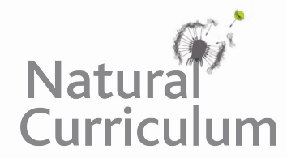
Learning Objective
We are learning how to extend sentences using the coordinating conjunctions and, but and or.

Challenge 1
The following sentences about the ibex have been split and jumbled up. Can you use lines to link the two halves of each sentence back together again? Before drawing a line, be sure to say out loud the whole sentence to hear that it makes sense.

The ibex is a herbivore which eats grass, moss, flowers, leaves |  | but it must also eat minerals found only in certain rocks.
If you go for a walk in the mountains of Italy, |  | the scientific name for the animal is ibex.
The male and female ibex both have horns, |  | you might glimpse the spectacular sight of mountain goats defying gravity.
An ibex’s hooves might look dainty, |  | and twigs.
Some people call it the mountain goat, but |  | but they allow the ibex to climb up vertical walls.
An ibex eats all sorts of vegetation, |  | but a male’s horns are typically 3 times the size of a female’s horns.

Challenge 2
Complete the following passage about the ibex by inserting the best conjunction – and, or, but into the blank spaces.

You might not believe your eyes when you see ibexes climbing vertical walls ____ you should not be surprised. Ibexes have special hooves, amazing balance ___ nerves of steel that allow them to undertake the most incredible of climbs. They eat mostly vegetation, like leaves ____ flowers, ____ also need to eat small amounts of essential mineral found only in rocks ___ stones. Mother ibexes must encourage their kids to climb from a young age ___ the young animals will not learn how to get the essential minerals they need for a healthy life.

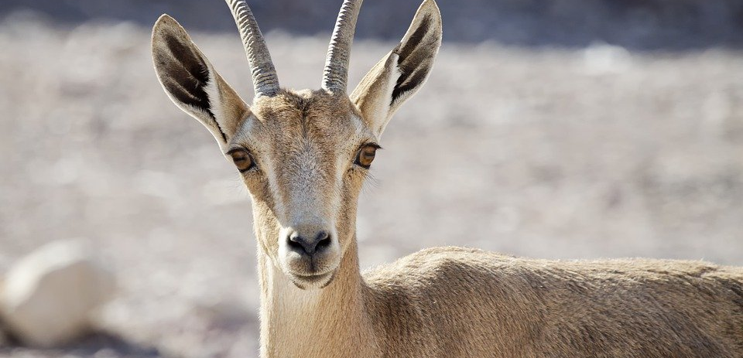
Challenge 3
Using some of the descriptive words from the Word Wall, write your own extended sentences about the ibexes featured in the main film clip. Your sentences must contain a coordinating conjunction (and, but, or).

Word Wall
and, but, or
mountain goat
ibex
fearless
kid
gravity-defying
nail-biting
nimble
sure-footed
courageous
strong bond
dam

