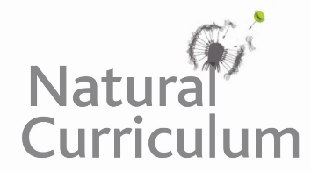
Learning Objective
We are learning how to use the first two or three letters of a word to check its meaning and spelling in a dictionary

Challenge 1
Match the words to the correct definitions below. Draw a line to match the word to its definition.
nocturnal
a yellow powder made by a flower, which fertilises seeds
pollen
this is where animals use sound waves to understand where objects are
adapt
a creature that is active at night
mammal
something that changes or can be changed
echolocation
a warm blooded animal, with hair or fur that gives birth to its babies

Challenge 2
Read each of these words. Put them in order alphabetically. You will need to look at the second and third letter.
magnificent
mammal
nutritious
night-time
nectar
nocturnal

A B C D E F G H I J K L M N O P Q R S T U V W X Y Z

Challenge 3
Use your dictionary skills to find the definitions of the words in bold and create a glossary for the paragraph below. A glossary is like a mini dictionary that shows the reader the meanings of words that appear in a text (see below). Notice how it is organised in alphabetical order.

Bats are mammals. They are the only mammals capable of sustained flight. Most bats are insectivores and use echolocation to detect their prey. Others are frugivores and some (like the Mexican long-tongued bats) are nectivores. Most bats are nocturnal and many roost in caves. Bats can vary greatly in size. The largest bat is the golden-crowned flying fox which has a wingspan of 1.7 metres. The smallest bat is Kitti’s hog-nosed bat, which has a wingspan of just 15 centimetres.
Glossary
bat – a nocturnal mouse-like flying animal
nectar – a sugary liquid produced by plants
tongue – a fleshy mouthpart used for tasting and licking

