Learning Objective
We are learning how to use the correct determiners ‘a’ and ‘an’ in our writing.
‘An’ – use this determiner before words that start with a vowel sound.
‘A’ – use this determiner before words that don’t start with a vowel sound.

Challenge 1
With your teacher, read the following sentences and complete them by choosing the correct determiner ‘a’ or ‘an.’

1) The BBC was able to use ____________ harmless hummingbird spy to film the butterflies.
2) Eastern monarch butterflies can be found in __________ area of Central Mexico.
3) It is ____________ outstanding spectacle to watch.
4) Building the Spy Hummingbird wasn’t ________ easy job!
5) Special muscles gives them ____ advantage for long-distance flight.
6) The number of monarch butterflies has fallen by _____ estimated 80 percent.
7) The tall tree is completely full with _____________ kaleidoscope of butterflies.

Challenge 2
Read the following sentences and circle where you think ‘a’ or ‘an’ has been used incorrectly. The first one has been done for you.

1) The monarch butterfly is an beautiful insect.
2) As a much loved species, monarchs have been filmed many times.
3) After a hour passed by, the Spy Hummingbird returned to the scientists.
4) The milkweed plant had more than just a single egg on it!
5) It was a colourful display when the monarch butterflies finally arrived in the forest.
6) A Spy Hummingbird is an perfect spy since it is so quiet.
Now compare your answers with a shoulder partner. Can you explain why you did/didn’t circle ’a’ or ‘an.’
Challenge 3
Using some of the descriptive words from the Word Wall, see if you can write 3 of your own sentences about monarch butterflies that include the correct use of the determiners ‘a’ or ‘an.’
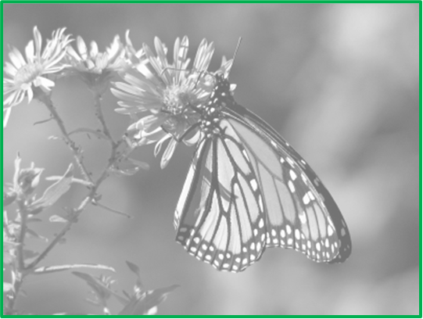
Word Wall
an
a
colourful
monarch butterflies
delicate
milkweed
kaleidoscope
butterfly forest

