Learning Objective
We are learning how to use expanded noun phrases.

Challenge 1
Expand the noun phrases in the sentences below by selecting an appropriate adjective from the following list:
helpless
striking
colourful
tiny
toxic
damp
dark
determined
deadly

- The ____________ forest floor is home to the __________ poison dart frog.
- The ________________ poison dart frog has enough poison to make the largest predator regret taking a bite.
- Male poison dart frogs look after their young in a ____________ pool of water.
- The ________________ tadpole needs water to survive.
- The ______________ father carried his young on his back.

Challenge 2
Highlight the expanded noun phrases in the passage below. Remember to include the determiner, adjective(s) and noun.

When you are a soft-skinned animal living in a dark, dense forest, you need a bright skin colour to tell any interested predators, “Eat me and you’ll regret it!” The vivid colour is not just to warn predators though. To other poison dart frogs, a bright, shiny skin shows that this is a healthy, strong frog. A pale coloured frog will not take on an opponent that is more brightly coloured than himself, as he knows he is not likely to come away from the encounter as the winner. For these tiny frogs, their colour is vital for protection and for finding a good mate. For them, life is colour.

Challenge 3
Imagine you are working with a BBC film crew in the Amazon Rainforest. After several days of searching, you finally see a poison dart frog. Write a diary entry, describing the day you found the frog. Try and include some of the words from the Word Wall and use expanded noun phrases for extra detail. You could use the following sentence to get started:

Dear Diary,
Waking to the exotic sounds of the rainforest, we continued our search for the famous poison dart frogs.

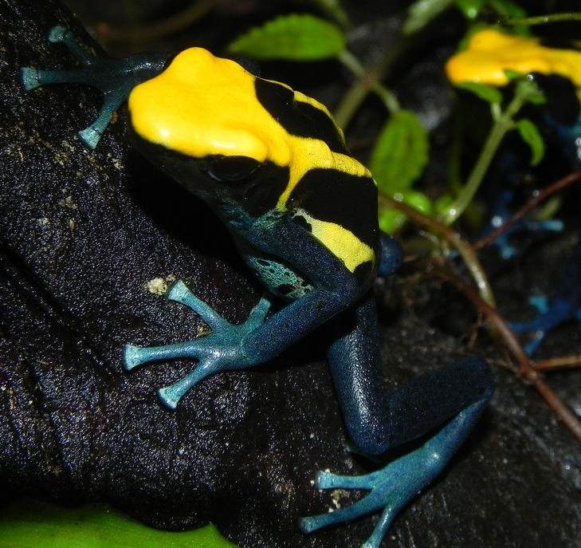
Word Wall
colourful
rainforest
poison dart frog
scarlet
amphibian
leapt
bulging eyes
sticky tongue
wrestled
poisonous
warning

