Learning Objective
We are learning how to use inverted commas.

Challenge 1
Someone has forgotten to put the inverted commas (speech marks) around the spoken words in the sentences below. Can you put them in the right places?

1) I may only be squirrel-sized, but I’m a skilful fighter, said the plucky prairie dog.
2) You’ll need to take cover. There’s a honey badger approaching, warned the owl.
3) Beware! There could be a snake in our burrow, said their father nervously.
4) The young prairie dog pup asked his older brother, Will you groom me now?
4) Don’t go that way, instructed mum. The entrance to the burrow is this way.
5) Leave me alone you pesky owl! shouted the angry badger. Why are you bothering me?
6) The coast is clear! cried the eagle-eyed prairie dog. You can all come out now.
Challenge 2
Use your knowledge of inverted commas (speech marks) to write what this honey badger and prairie dog are saying to each other in your Literacy book. Don’t forget to use a reporting clause to tell your reader who is speaking and how they might be feeling.

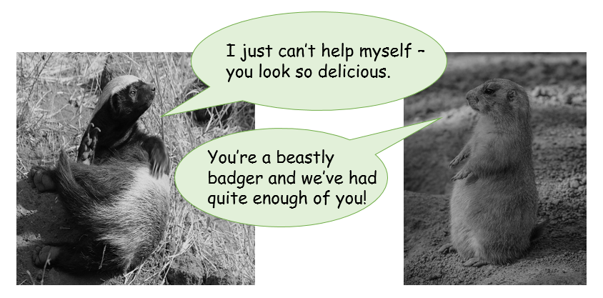

Challenge 3
Use your knowledge of inverted commas (speech marks), continue the conversation between the honey badger and the prairie dog (above). Will you introduce a third
character? A burrowing owl perhaps? Don’t forget to use reporting clauses to tell your reader who is speaking and how they might be feeling as well as describing any actions that the animals might be doing.

