Learning Objective
We are learning how to demarcate sentences with capital letters, full stops, question marks and exclamation marks.

Challenge 1
Complete each of the following sentences with a correct punctuation mark, having decided if it is a sentence, question, command or exclamation.

- The team have to walk uphill for about 5km to get to the release site __
- This is the last time that these birds will see the inside of a cage __
- What an amazing place this rainforest is ___
- Did you know that scarlet macaws can eat fruits that would poison other animals __
- The amount of scarlet macaws in Guatemala has just increased by 5% ___
- Stop chopping down the rainforest ___

Challenge 2
Read the following statements about the scarlet macaw. Underneath write a question/ command or exclamation using the information in the statement to help. Remember your punctuation! (See example)
Statement: The team has made history as this is the first time captive bred scarlet macaws have been released into the wild in Guatemala.
Question: Have scarlet macaws been released into the wild in Guatemala before?

1. Statement: Scarlet macaws like to feed on fruit, nuts, insects and snails.

Question: _______________________________________________________
2. Statement: Their loud calls, squawks and screams echo throughout the rainforest.
Exclamation:_____________________________________________________
3. Statement: Many scarlet macaws are trapped to be sold as pets.
Command:________________________________________________________
4. Statement: Macaws latch onto branches and examine items with their powerful claws.
Question:________________________________________________________
Challenge 3
Imagine that you were a member of the team that released the scarlet macaws into the wild. Write about this incredible moment using words from the Word Wall. Check that every sentence begins and ends in the correct way.

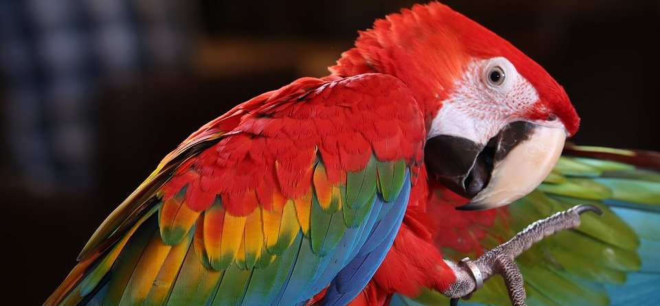
Word Wall
preening
canopy
released
squawking
caged
freedom
exotic
hooked beak
brightly coloured
rainforest
scarlet macaw

