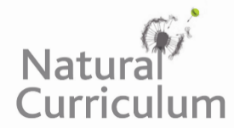
Learning Objective
We are learning how to use capital letters in our writing.

Challenge 1
Identify which lower case letters need to be turned into capital letters and correct with your proofreading pen or pencil.

1) the sun bear is the smallest of all the bear species
.
2) sun bears can be found in the tropical forests of borneo.
3) if given the chance, i would love to see a sun bear in the wild.
4) has sir david attenborough ever seen a sun bear in the wild?
5) the honey-loving sun bear called noah was halfway up the tree.
6) last tuesday, sunny the sun bear built a bed of twigs and leaves to sleep on.
Challenge 2
Rewrite each of the following sentences, using your knowledge of when capital letters need to be used.
- i have read about sun bears in the national geographic magazine.
_________________________________________________________________
- i don’t think they have sun bears at bristol zoo.
_________________________________________________________________
- i’ m going to nickname this sun bear honey monster!
_________________________________________________________________
- from kinabalu airport in borneo, we headed deep into the rainforest.
_________________________________________________________________
- i loved watching the sun bears on the bbc natural history programme.
_________________________________________________________________
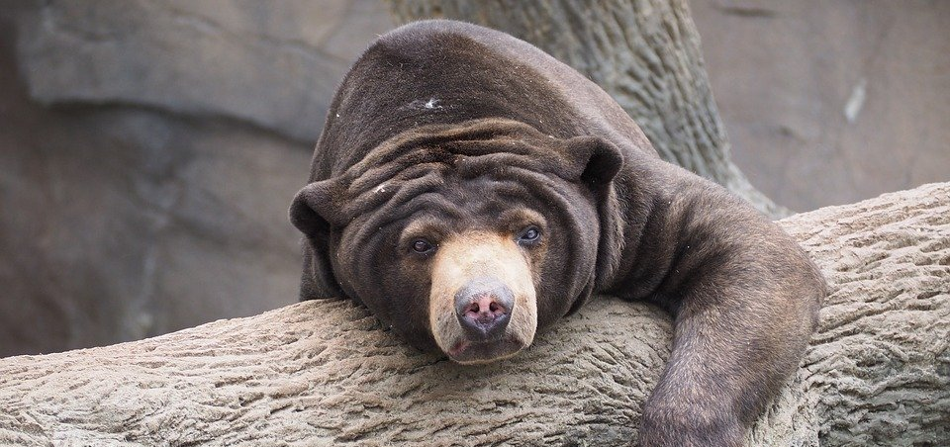
Word Wall
Challenge 3
Using some of the descriptive words from the Word Wall, write a short paragraph that describes a sun bear climbing a tall tree in Borneo to reach a honeycomb. Take extra care to make sure there are capital letters in all the correct places!
miniature acrobat
golden chest
honey-loving
climbed
Borneo rainforest
endangered
scaled
razor-sharp claws
cubs
sun bear

