**Learning Objective**

We are learning how to demarcate sentences with capital letters, full stops, question marks and exclamation marks.

**Challenge 1**

**Complete each of the following sentences with a correct punctuation mark, having decided if it is a sentence, question, command or exclamation.**

1. I can’t believe how small that leaf chameleon is __
2. Do you think that leaf chameleon is playing dead __
3. Be careful where you tread ___
4. Madagascar is the world’s fourth largest island __
5. The outer layer of a chameleon’s skin is see-through ___
6. Why do chameleons’ eyes move in different directions ___

**Challenge 2**

**Read the following statements about the leaf chameleon. Underneath write a question/ command or exclamation using the information in the statement to help. Remember your punctuation! (See example)**

Statement: Chameleons catch insects by firing out their long, sticky tongues.

**Question:** How do chameleons catch insects?

**1. Statement:** There are over 150 different species of chameleon.

**Question: _______________________________________________________**

**2. Statement:** Many chameleon species are endangered because of rainforest destruction.

**Exclamation:_____________________________________________________**

**3. Statement:** It is not a good idea to keep a chameleon as a pet.

**Command:________________________________________________________**

**4. Statement:** In Africa, snakes like the boomslang and the vine snake prey on chameleons.

**Question:___________________________________________________** **_____**

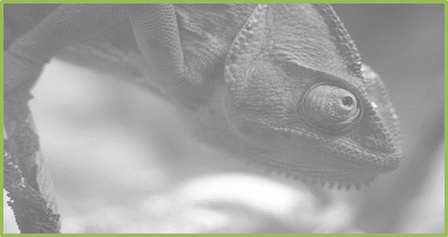

* **Challenge 3  
  Imagine that you are an explorer, exploring a remote rainforest region of Madagascar. While taking a rest on the forest floor, a tiny leaf chameleon climbs up your leg! Write a travel journal entry about your encounter with this curious creature.**

**Word Wall**

miniscule

leaf chameleon

rainforest

long, sticky tongue

Madagascar

leaf litter

gripping feet

rotating eyes

camouflaged