Learning Objective
We are learning to use commas in lists.

Challenge 1
Use your proofreading pen or pencil to add commas to the correct places in the following sentences:
1) Most reptiles are cold-blooded have scaly skin and lay eggs.
2) The Galapagos islands are home to many reptile species such as marine iguanas land iguanas and giant Galapagos tortoises.
3) Marine iguanas have blunt snouts sharp teeth and flattened tails.
4) Marine iguanas are expert divers climbers and swimmers.
5) Marine iguanas feed on red algae green algae and some sea plants.

Challenge 2
Take out the unnecessary ‘ands’ from these sentences and rewrite them as a list.

1) The marine iguana was brave and quick-witted and determined.
________________________________________________________________________________________________

2) Small marine iguanas can be eaten by Galapagos hawks and snakes and domestic cats and rodents.
________________________________________________________________________________________________

3) During the mating season, marine iguanas can be bright green and bright red and dull green or brick red.

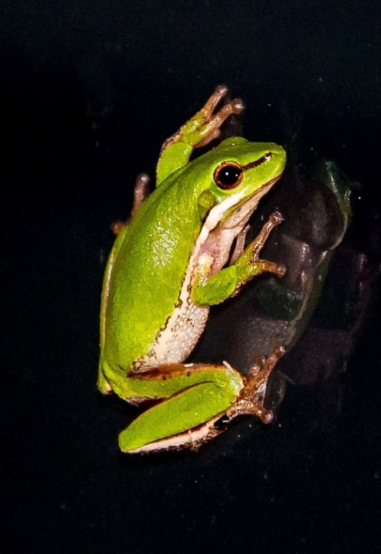
______________________________________________________________________
Challenge 3
You have been asked to write the narration for a different nature programme that also features a marine iguana. In this clip, a marine iguana can be seen feeding on algae at the bottom of the ocean. Try to use some of the descriptive words from the Word Wall and include two list sentences that are correctly punctuated. You could start with the following sentence:
As the waves battered the coast, the
iguana plunged into the ocean.

Word Wall

algae
nibbled
razor-sharp teeth teeth
salty wig
blunt snout
long claws
leapt
flattened tail
scaly reptile
Galapagos
marine iguana

