Learning Objective
We are learning how to use the correct determiners ‘a’ and ‘an’ in our writing.
‘An’ – use this determiner before words that start with a vowel sound.
Vowels - a, e, i, o and u
‘A’ – use this determiner before words that don’t start with a vowel sound.

Challenge 1
With your teacher, read the following sentences and complete them by choosing the correct determiner ‘a’ or ‘an.’

1) The money spider can walk on the water because it is ____ light weight.
2) ____ money spider is a very tiny species of spider.
3) ____ evening breeze will not harm the money spider, because it uses the wind to travel.
4) Money spiders can also be known as sheet weavers because their webs look like ____ sheet of silk.
5) The money spiders spin their webs around ____ area on the ground.
6) These spiders can travel up to 100 miles in the wind, which is quite ___ long distance for a tiny spider!
Challenge 2
Be the teacher! Read the following sentences and put a tick or cross next to each sentence to show if ‘a’ and ‘an’ have been used correctly. Compare your answers with a partner and explain why you chose a tick or a cross.

Sentence | Is it correct? (tick or cross)
An species of money spider called Lepthyphantes tenuis is thought to be the most common species living in the UK.
An goldcrest bird will happily eat money spiders.
The money spider has an black body and thin, brown legs.
The scientist needed to use a microscope to identify the exact species of money spider.
The money spider uses its front two legs like an sail to help it move in the wind.
After being attacked by a bird, it was now an one-legged spider. (Take extra care with this one!)
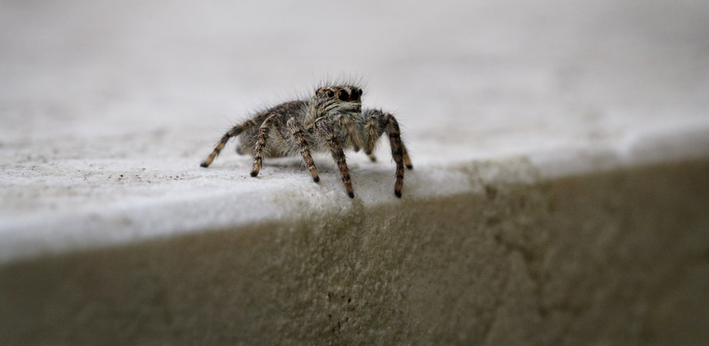
Challenge 3
Using some of the words in the Word Wall, create your own sentences that describe the appearance and behaviour of money spiders. Make sure you use the correct determiner ‘a’ or ‘an’ depending upon the sound the following word starts with.
Word Wall

a
an
money spider
silk web
breeze
scientist
paintbrush
miniature marvel
strategy
surface tension
sailed
dainty

