Learning Objective
We are learning how to use expanded noun phrases to describe and specify.

Challenge 1
Expand the noun phrases in the sentences below by selecting an appropriate adjective from the following list:
lazy
deadly
playful
golden
frightened
sweet
high
bromeliad
unusual

- Both male and female tamarins have long ________ manes.
- The golden–headed lion tamarins spent the day foraging for ________ fruits.
- The ________ youngsters were swinging from the _______ branches.
- The ___________ plant was home to lots of _________ creatures.
- As the ___________ wildcat approached, the ___________ tamarins scattered in all directions.
- The father carried his _______ youngster on his back.

Challenge 2
Highlight the expanded noun phrases in the passage below. Remember to include the determiner, adjective(s) and noun.

Laurie and his team of scientists were trekking through a lush, Brazilian rainforest. They were on a mission to locate and study a family of golden-headed lion tamarins. All of a sudden, they heard the familiar vocal noises of excited tamarins. The scientists were thrilled to see the family of rare and endangered lion tamarins moving from branch to branch high above. The devoted father was at the front, with a youngster clinging tightly to his long golden mane. Suddenly, they stopped and used their long fingers to probe deep into a tree trunk, where they found lots of juicy grubs to eat.

Challenge 3
Imagine you are working with a BBC film crew deep in the Amazon Rainforest. After several days of searching, you finally see a family of golden-headed lion tamarins. Write a diary entry, describing this encounter. Try to include some of the words from the Word Wall and use expanded noun phrases for extra detail. You could use the following sentence to get started:

Dear Diary,
Waking to the exotic sounds of the rainforest, we continued our search for the magnificent golden-headed lion tamarins.

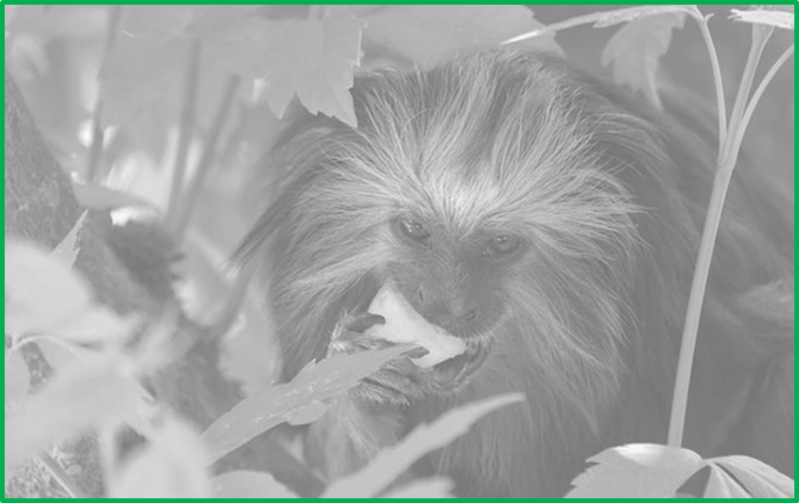
golden-headed lion tamarin
mane
bromeliad
canopy
miniature
squirrel-sized
delicious
hitched
devoted father
leapt
eating, grooming, playing
Word Wall

