**Learning Objective**

We are learning how to add numbers with up to 3 digits using column addition **(with one exchange).**

**Challenge 1**

**Read each word problem carefully and highlight the important information. Solve each word problem by drawing 100s, 10, and 1s counters and using column addition.**

1) In the first year, a beekeepers’ bees made 124 pots of honey. In the second year, the bees only made 36 pots of honey. **How many pots of honey did the beekeepers’ bees make altogether over these two years?**

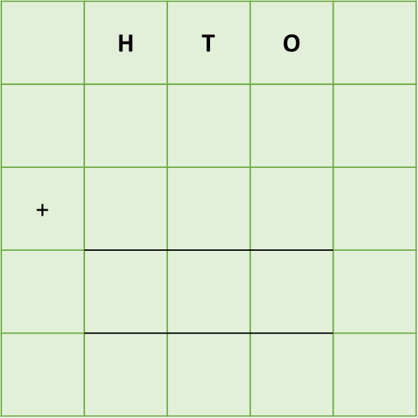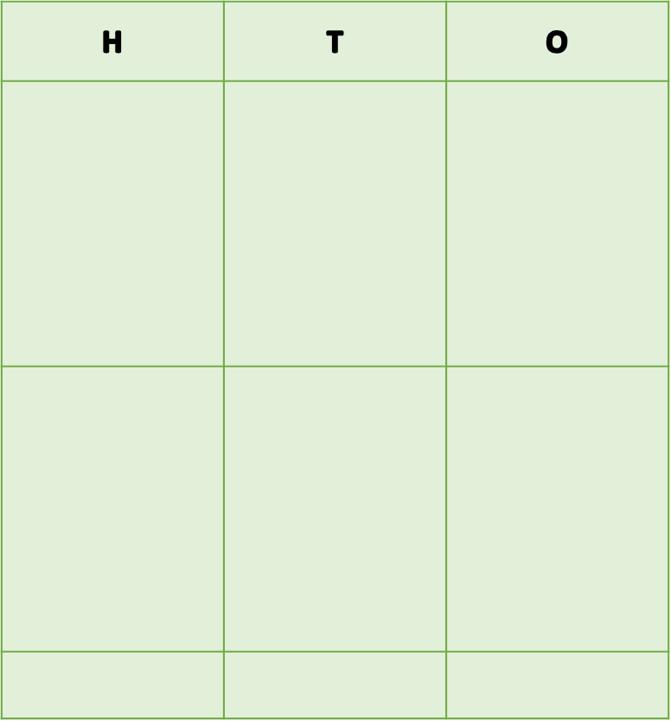



Answer:

2) In a single week in winter, a queen honey bee laid a total of 1,235 eggs in her honeycomb nest. On Monday she laid 236 eggs. On Tuesday she laid 328 eggs. **How** **many eggs did the queen bee lay altogether on these two days in winter?**



Answer:

3) A swarm of 98 wasps were attacking a honey bee nest. 226 worker honey bees tried to protect their nest from above, while 392 tried to protect their nest from below. **How many worker honey bees were protecting the nest altogether?**

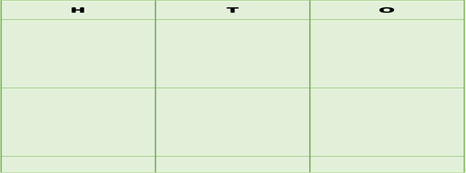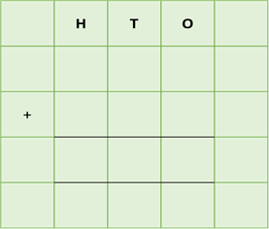

Answer:

4) There were three underground bumblebee nests in a garden. In the first nest, there were 345 bumblebees. In the second nest, there were 589 bumblebees. In the third nest, there were 463 bumblebees. **How many bumblebees were there altogether in the two smallest nests?**

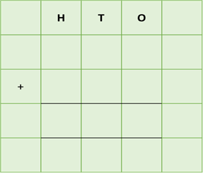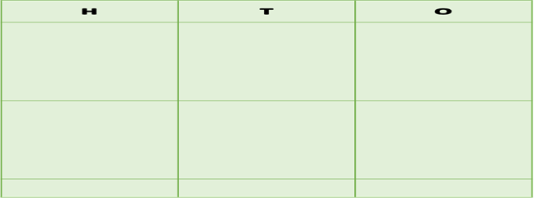

Answer:

5) In a chunk of honeycomb, 322 hexagonal cells were filled with honey and 164 hexagonal cells were filled with bee larvae (tiny grubs). The remaining 131 hexagonal cells were empty. **How many hexagonal cells were there altogether in the honeycomb?**

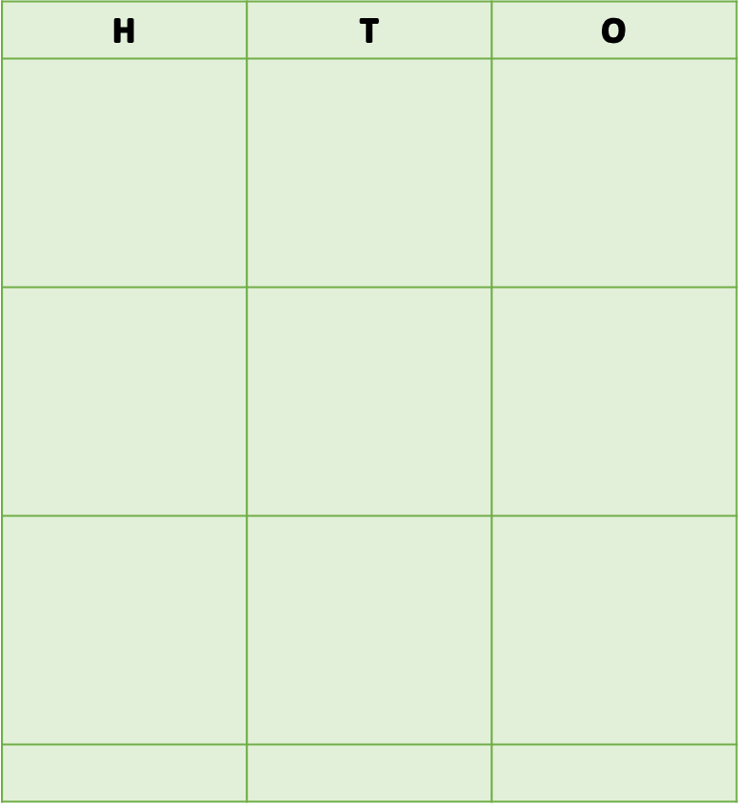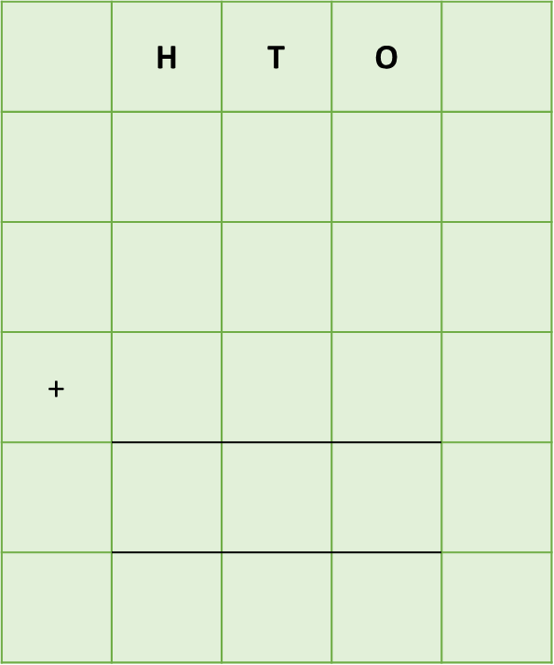

Answer:

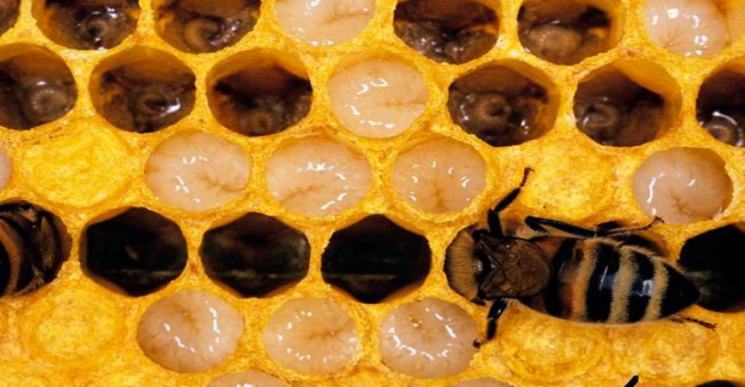**Challenge 2  
Using your knowledge of bees and some of the words from the Word Wall, write your own word problem that requires an exchange. Using column addition, write the solution to your word problem on the grid below.**

filled

flowers

hexagons

stung

eggs

collected

pollen

landed

long-legged

scrambled

poisonous

brightly coloured

**______________________________________________________________________________________________________________________________________________________________________________________________________________________________**

honey bees

**Word Wall**