Learning Objective
We are learning how to subtract a 3-digit number from a 4-digit number using column subtraction (with one or more exchanges, but not including an exchange across more than one place value).

Challenge 1
Read each word problem carefully and highlight the important information. Solve each word problem by drawing 100s, 10, and 1s counters and column subtraction.

1) A herd of 748 bison were eating grass. Within this herd, the largest male (bull) bison weighed 1,056 kilograms and the largest female (cow) weighed 534 kilograms. What was the difference in weight between the two bison?
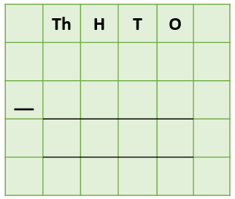

Answer:

2) A small herd of bison had a total of 2,345 biting flies on their bodies. After rolling around in mud, they managed to remove a total of 654 biting flies. How many biting flies remained on the herd?
Answer:

3) In Yellowstone Park, a herd of 3,346 bison were eating grass. The herd included 124 young calves without horns and 3,222 adults with horns. Of these adults, 713 bison had damaged horns. How many bison had undamaged horns?

Answer:
4) On the 4th August, 2021, a total of 3,456 people visited Yellowstone Park. Of these visitors, 927 did not manage to see the bison herd. (They are shy creatures!) How many visitors did manage to see the bison herd on this day?

Answer:

5) A female bison travelled a total distance of 2,554 metres to find fresh grass. It ran at 35 miles per hour for a distance of 687 metres before jumping over a fence (it’s true, bison can jump!) and then walked the remaining distance. How far did the female bison walk?

Answer:

Challenge 2
Using your knowledge of bison and some of the words from the Word Wall, write your own word problem that has an exchange across more than one place value. Use column subtraction to write your answer to the problem.
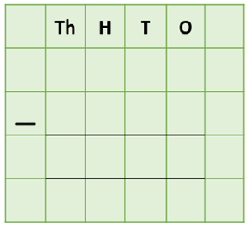
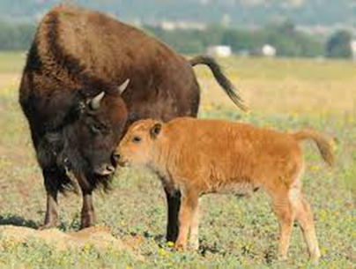
______________________________________________________________________________________________________________________________________________________________________________________________________________________________
calf
distance
heavy
feeding
grazing
fighting
herd
bison
watching
Word Wall

