Learning Objective
We are learning how to subtract a 2-digit number from a 3-digit number using column subtraction (with one exchange, but not exchanging across more than one place value).

Challenge 1
Read each word problem carefully and highlight the important information. Solve each word problem by drawing 100s, 10, and 1s counters and column subtraction.

1) Off the coast of South Africa, a pod of 174 bottle-nosed dolphins were surfing the waves. Of these dolphins, 67 were female. How many male dolphins were there in the pod?

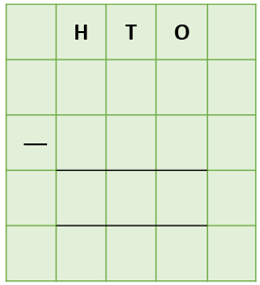
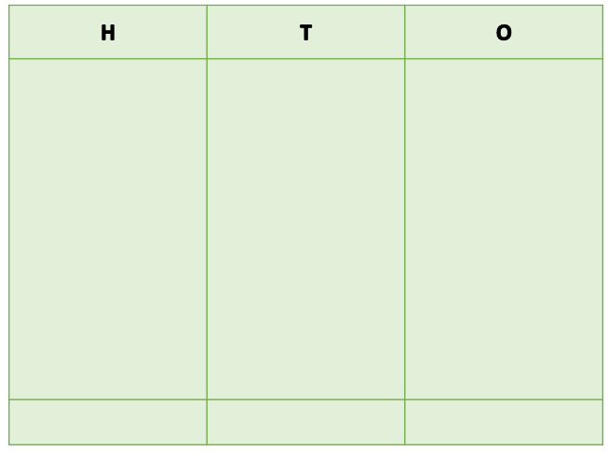
Answer:

2) A bottle-nosed dolphin took 2 days to swim a distance of 164 kilometres. On the first day, it swam 81 kilometres. How far did it swim on the second day?
Answer:

3) In an area of the Atlantic Ocean, 247 dolphins and whales became tangled up in large fishing nets. Of these animals, 154 managed to free themselves. How many dolphins and whales did not manage to escape?

Answer:
4) A killer whale (a member of the dolphin family) give birth to a male calf and a female calf. The female calf weighed 134 kilograms at birth. The male calf weighed 181 kilograms at birth. What was the difference in weight between the two calves?

Answer:

5) A long-beaked dolphin, who was playing with a large pod of 137 other long-beaked dolphins had 240 teeth. In a collision with a boat, the dolphin lost 56 teeth. How many teeth did the dolphin have left?

Answer:

Challenge 2
Using your knowledge of dolphins and some of the words from the Word Wall, write your own word problem that has one or more exchanges. Use column subtraction to write your answer to the problem.
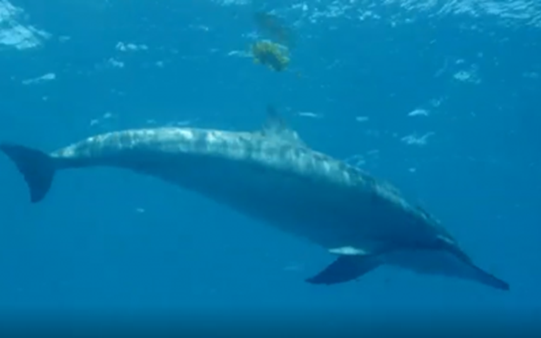
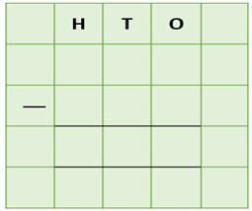
______________________________________________________________________________________________________________________________________________________________________________________________________________________________
shark
disappeared
fish
spun
ocean
dived
pod
journey
dolphin
Word Wall

