Learning Objective
We are learning how to subtract a 2-digit or a 3-digit number from a 3-digit number using column subtraction (with one or more exchanges, but not exchanging across more than one place value).

Challenge 1
Read each word problem carefully and highlight the important information. Solve each word problem by drawing 100s, 10, and 1s counters and column subtraction.

1) A herd of elephants needed to travel 195 kilometres to find their favourite waterhole. So far they have travelled 49 kilometres. How much further do the herd need to travel?

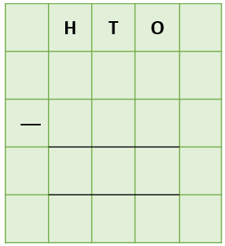
Answer:

2) A new-born elephant (calf) was helped to its feet by its mother. It weighed 155 kilograms. Her older sister was 28 kilograms lighter when she was born. How heavy was the older sister at birth?
Answer:

3) A large male (bull) elephant spent 2 days drinking from a river. During this time he drank a total of 324 litres of water. On his first day at the river, he drank 136 litres of water. How many litres of water did he drink on the second day?

Answer:
4) 245 biting insects had landed on an elephant’s bottom. The elephant waved its tail from side to side and managed to get rid of 157 of these biting insects. How many insects were left on the elephant’s bottom?

Answer:

5) A farmer, who owned 425 acres of land, fired his gun to prevent a super herd of 327 elephants from destroying his crops. The frightened elephants scattered in 2 different directions. 168 elephants ran in an easterly direction. The remaining elephants ran in a westerly direction. How many elephants ran in a westerly direction?

Answer:

Challenge 2
Using your knowledge of elephants and some of the words from the Word Wall, write your own word problem that has one or more exchanges. Use column subtraction to write your answer to the problem.
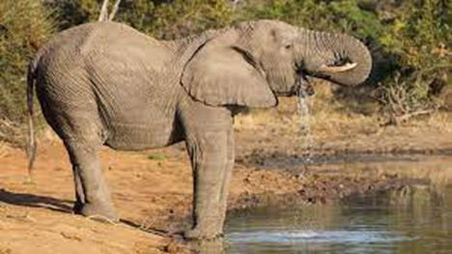
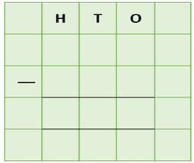
______________________________________________________________________________________________________________________________________________________________________________________________________________________________
Elephantss
Africa
squirted
poacher
trumpeted
journey
herd
waterhole
tusks
Word Wall

