Learning Objective
We are learning how to subtract a 3-digit number from a 3-digit number using column subtraction (with one or more exchanges, including an exchange across more than one place value).

Challenge 1
Read each word problem carefully and highlight the important information. Solve each word problem by drawing 100s, 10, and 1s counters and column subtraction.

1) After a storm, 427 jellyfish were washed up on a UK beach. Of these jellyfish, 156 were barrel jellyfish. All of the others were moon jellyfish. How many moon jellyfish were washed up on the beach?

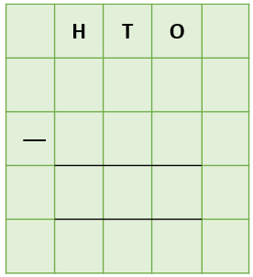
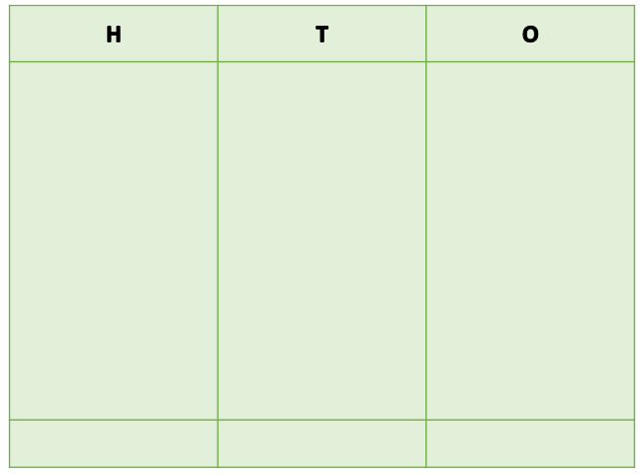
Answer:

2) In a turtle attack, a jelly fish lost 146 of its stinging tentacles. If the jellyfish had 327 tentacles before the attack, how many tentacles did it have after the attack?
Answer:

3) The bell-shaped body of a dark purple lion’s mane jellyfish was 165 centimetres across. The largest lion’s mane jellyfish are 230 centimetres across. How many more centimetres did the lion’s mane jellyfish need to grow to reach this size?

Answer:
4) Scientists have identified 200 different types of jellyfish. If a diver had recorded seeing 136 different types of jellyfish, how many different types of jellyfish had the diver not yet seen?

Answer:

5) 135 tiger sharks were swimming close to the shore, where a swarm of 304 jellyfish were drifting. During the night, a large, hungry tiger shark ate a total of 176 of these jellyfish. How many jellyfish were not eaten by the tiger shark?

Answer:

Challenge 2
Using your knowledge of jellyfish and some of the words from the Word Wall, write your own word problem that has an exchange across more than one place value. Use column subtraction to write your answer to the problem.
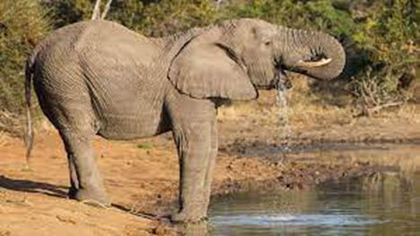
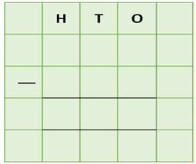
______________________________________________________________________________________________________________________________________________________________________________________________________________________________
sunbathing
eaten
glowing
feeding
washed-up
tentacles
stung
jellyfish
beach
Word Wall

