Learning Objective
We are learning how to add numbers with up to 3 digits using column addition (with no exchange).

Challenge 1
Read each word problem carefully and highlight the important information. Solve each word problem by drawing 100s, 10s, and 1s counters and using column addition.

1) In a woodland, 125 peacock butterfly caterpillars and 34 tortoiseshell butterfly caterpillars were feeding on nettle leaves. How many butterfly caterpillars were feeding on the nettle leaves altogether?
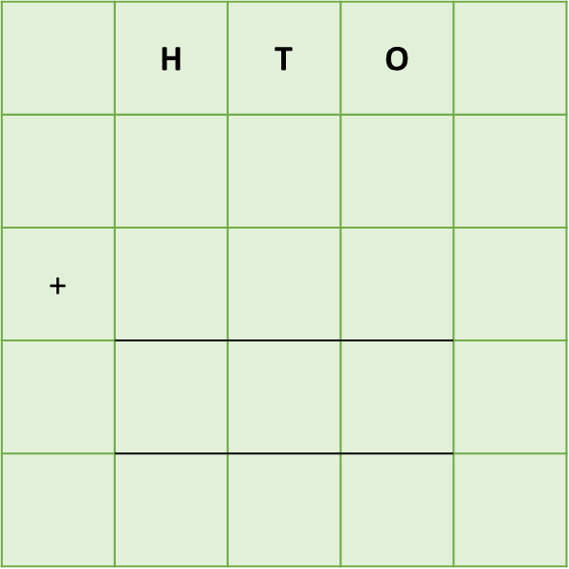
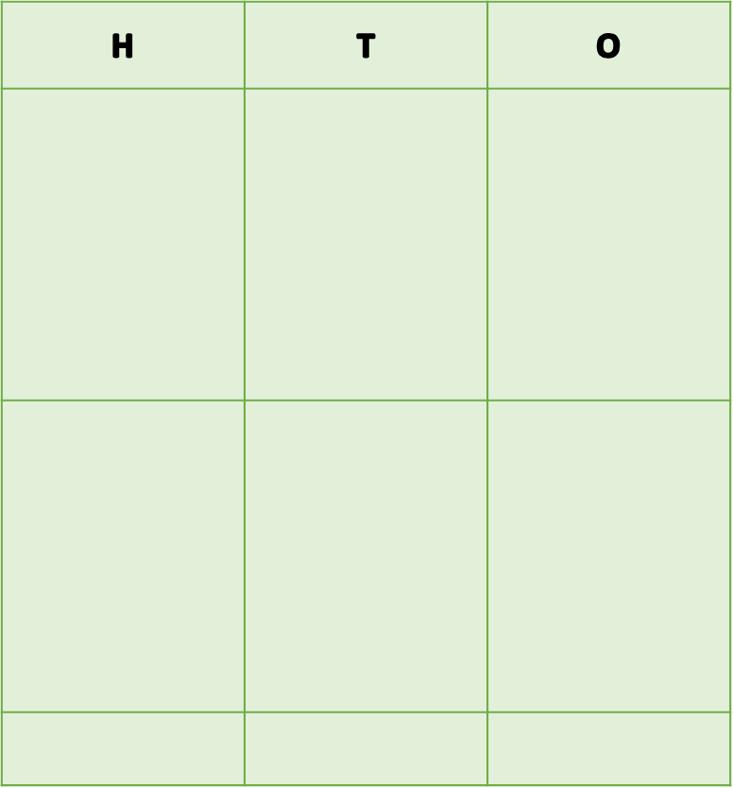

Answer:
2) On a single day in spring, a robin ate 234 butterfly caterpillars in the morning and a further 65 caterpillars in the afternoon. It also ate 54 spiders. How many butterfly caterpillars did the robin eat altogether?

Answer:

3) A butterfly lived for 336 days. During its short lifetime, it drank nectar from 343 purple flowers. It also drank nectar from 246 pink flowers and 67 white flowers. How many purple and pink flowers did the butterfly drink nectar from?
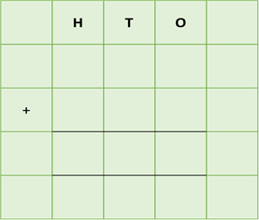

Answer:
4) On the first day of its epic journey through North America, a monarch butterfly flew 234 miles. On the second day, it flew 365 miles and on the third day it flew 128 miles. How far had the monarch butterfly flown after the first two days of its journey?

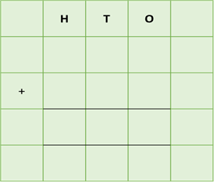

Answer:

5) In a noisy area of rainforest, where over 250 howler monkeys were calling to each other, hundreds of butterflies were flying around. Altogether, there were 256 owl butterflies, 122 daggerwing butterflies and 211 starry night butterflies. How many butterflies were there in this area of rainforest?
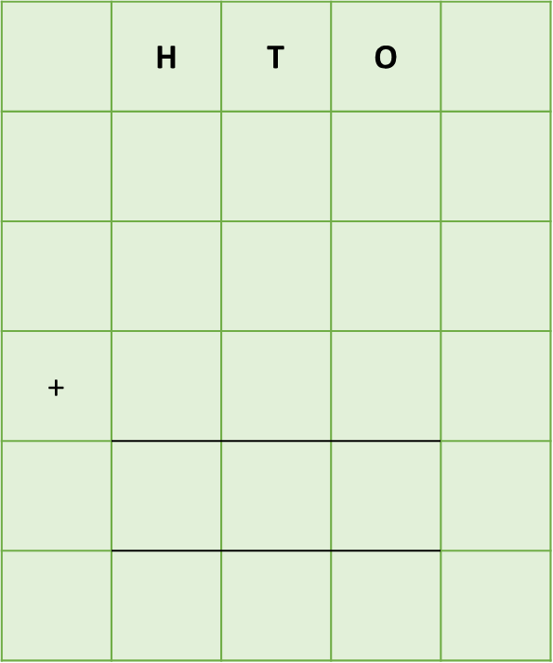

Answer:

Challenge 2
Using your knowledge of butterflies and some of the words from the Word Wall, write your own word problem (with or without an exchange). Using column addition, write the solution to your word problem on the grid below.
nectar
flowers
munched
landed
chrysalis
eggs
leaves

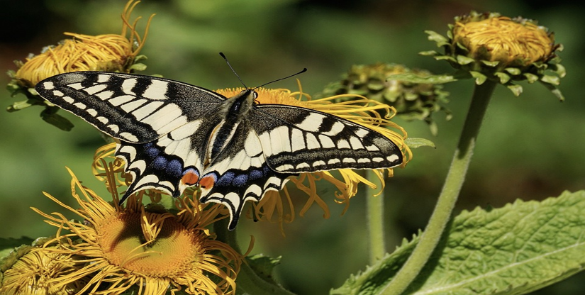
______________________________________________________________________________________________________________________________________________________________________________________________________________________________
caterpillars
butterflies
Word Wall

