**Learning Objective**

We are learning how to solve a natural world problem by using and applying our skills and knowledge of length and measurement.

**The Problem:**

The picture below shows what scientists think the complete skeleton of a titanosaur might have looked like.

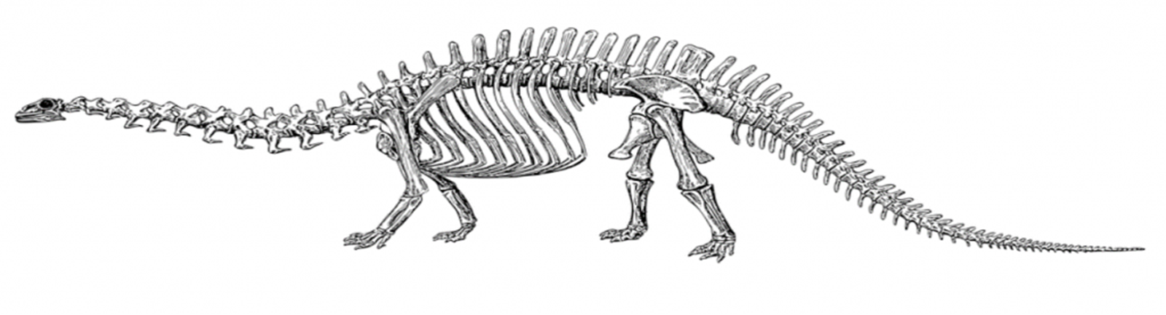

**From this picture and from the fossilised titanosaur femur bone featured in the clip, can you calculate the approximate length of this mighty dinosaur?**

**Recording:**

Use this space to show your working out*.*

**Answer:**

**I think a titanosaur would have had a length of around _______________**