**Learning Objective**

We are learning how to solve a natural world problem by using and applying our skills and knowledge of numberand fractions.

**The Problem:**

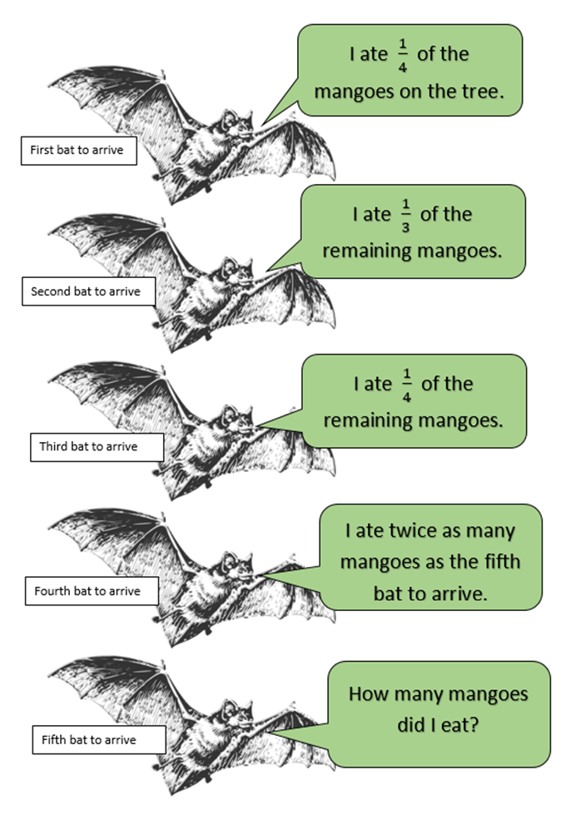In Kasanka National Park, there were**24** juicy mangoes on a mango tree. It wasn’t long before five straw-coloured fruit bats arrived at the tree one at a time. The number of mangoes that each bat ate is described below.

**1) If all the mangoes were eaten, how many mangoes did the fifth fruit bat to arrive at the tree eat?**

**Recording:**

Use this space to show your working out*.*

**Answer:** The fifth bat to arrive at the tree ate _______________ mangoes.

**2) What fraction of the total amount of mangoes that were on the tree to begin with did the fifth fruit bat eat?**

**Answer: _______________**