**Learning Objective**

We are learning how to solve a natural world problem by using and applying our skills and knowledge of statistics and bar charts.

**The Problem:**

The bar chart below shows the number of different creatures that were living in a Cornish rock pool.

**Using the clue card descriptions, can you work with a partner to label each bar with the correct rock pool creature name?**

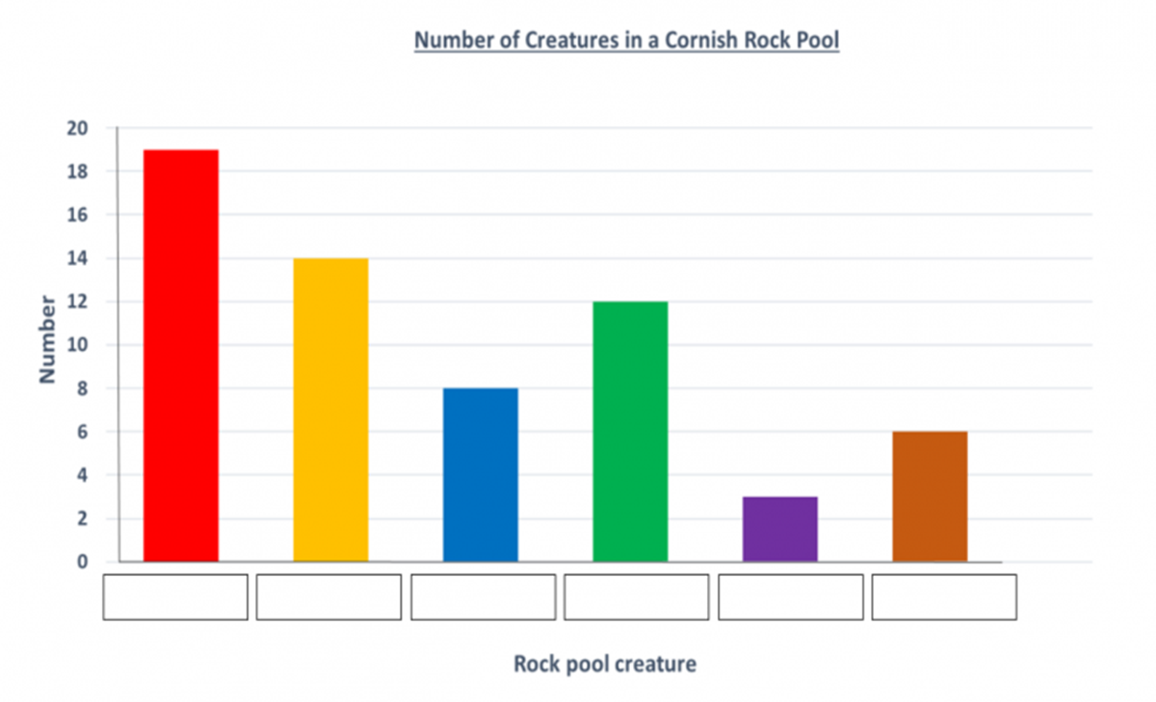

**Do all of the clue card descriptions need to be used?**

**________________________________________________________________________________________________________________________________**



