**Learning Objective**

We are learning how to solve a natural world problem by using and applying our skills and knowledge of measurement, length and distance (km & m).

**The Problem:**

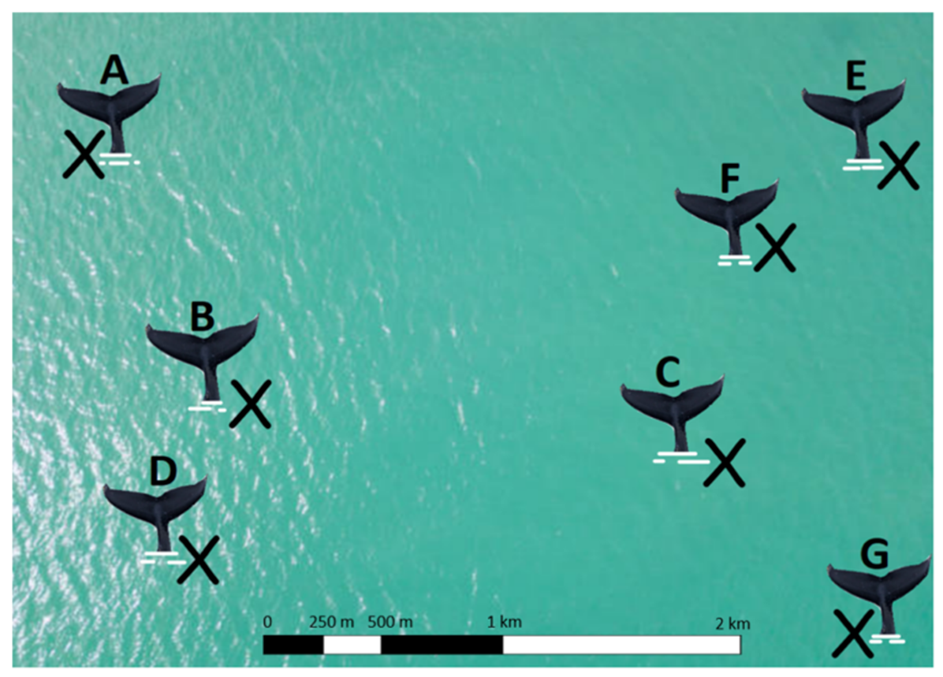In an area of the Atlantic Ocean, seven humpback whales (named A – G) are communicating with each other in pairs. You can see their different locations (marked with an x) on the ocean map below. You’ll notice that there is a bar scale at the bottom of the map that can be used to calculate how far the whales are apart.

1. How many pairs of whales are communicating across a distance that is less than 1 km?

Whale pairs:

e.g. D and B

Answer:

1. How many pairs of whales are communicating across a distance that is greater than 1 km but less than 2 km?

Whale pairs:

Answer:

1. How many pairs of whales are communicating across a distance that is greater than 2 km?

Whale pairs:

Answer: