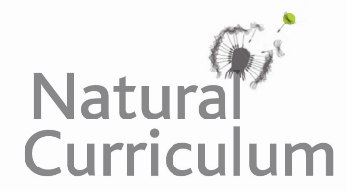**Learning Objective**

We are learning how to solve a natural world problem by using and applying our skills and knowledge of measurement and money.

**The Problem:**

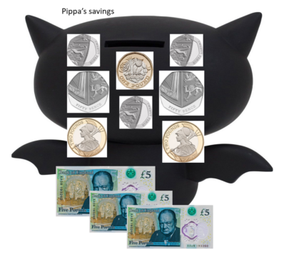Pippa was saddened to learn that populations of UK bat species had declined considerably over the past century due to the loss of habitat and food. To give bats a helping hand, Pippa’s family decided to make a bat box with the money she had saved.

To build the bat box, Pippa needed the following items:

**• 1 sheet of untreated wood**

**• 48 nails**

**• 2 brackets**

**• 4 wood strips**

**Will Pippa need to use all of her savings?**

**Recording:**

**Answer: ____________________**

Use this space to show your working out*.*

