**Learning Objective**

We are learning how to solve a natural world problem by using and applying our skills and knowledge of numberand fractions.

**The Problem:**

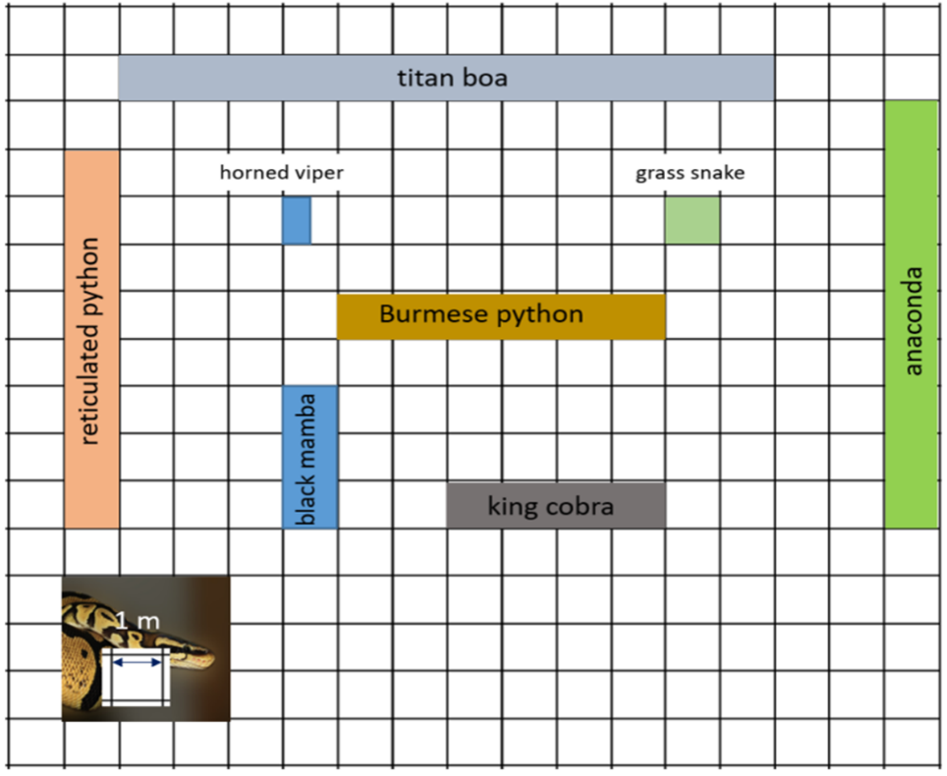

Mr Scales was a keen mathematician who loved reptiles. He decided to record the lengths of different snake species on squared paper (see opposite). Mr Scales discovered that the longest snake ever to have lived was the now extinct titan boa.

**Can you use your knowledge of fractions to make different comparative statements about the snakes that Mr Scales recorded?**

**Comparative Statements:**

1) (Example) The Burmese python is half the length of the titan boa.

2) ___________________________________________________________

3) ___________________________________________________________

4) ___________________________________________________________

5) ___________________________________________________________

6) ___________________________________________________________

7) ___________________________________________________________

8) ___________________________________________________________