**Learning Objective**

We are learning how to solve a natural world problem by using and applying our skills and knowledge of geometry and triangles.

**The Problem:**

At Cotham Gardens Primary School in Bristol, a giant redwood nicknamed ‘Big Red’ rises out of the playground. It is over 200 years old and towers above the school. One day, Benji, from class 3M, asked his teacher how tall Big Red was. His teacher didn’t know, but he thought it would be a great idea for the class to find out.

**How would you calculate the height of a tall tree like Big Red?**

**________________________________________________________________________________________________________________________________________________________________________________________________________________________________________________________**

Having carried out some research, Benji discovered that it was possible to calculate the height of a tree using a paper triangle!

**Can you estimate and then calculate the height of a tree by making a paper triangle and following the instructions (below)?**

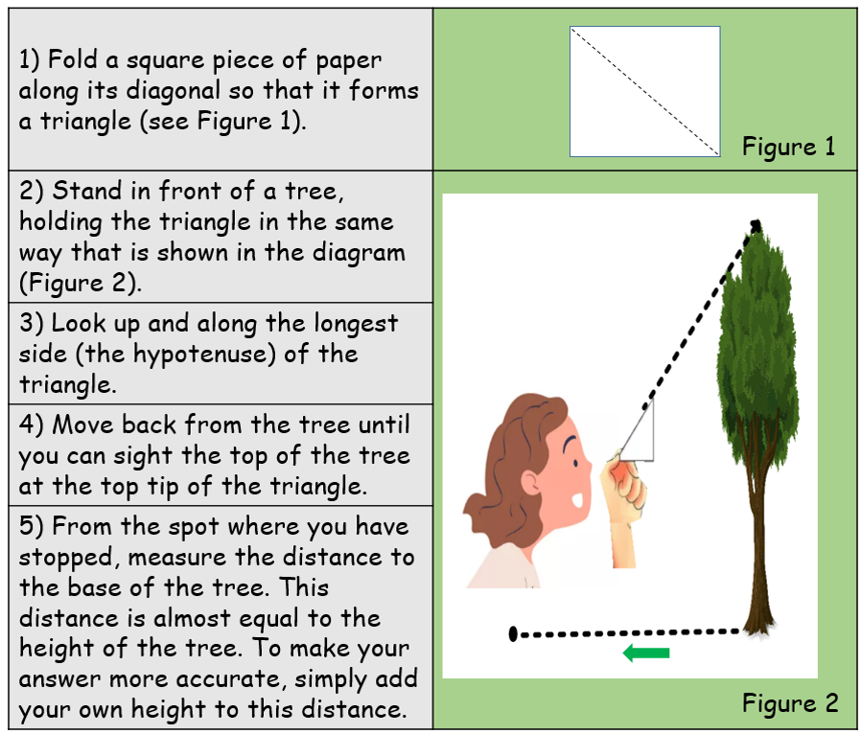

Solution 4

Solution 3