**Learning Objective**

We are learning how to solve a natural world problem by using and applying our knowledge and skills of number, multiplication and division.

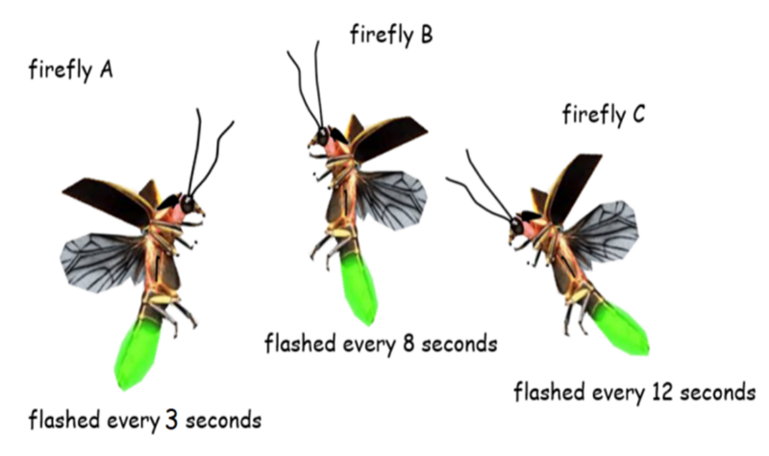**The Problem:**

Akio was watching 3 fireflies flash in the darkness. After flashing once, all at the same time, he noticed that the firefly closest to him flashed after every 3 seconds. He noticed that the firefly that was the furthest away flashed after every 12 seconds and a third firefly flashed after every 8 seconds.

**If Akio watched the fireflies for exactly one minute, can you calculate how many times he saw them flash at the same time?**

**Can you explain to a partner how you arrived at your answer? What was the same? What was different?**

**Recording:**

Use this space to show your working out.

**Answer:**

The fireflies flashed ___________ times together in one minute.