**Learning Objective:**

We are learning how to solve a natural world problem by using and applying our skills and knowledge of number, addition and subtraction.

**The Problem:**

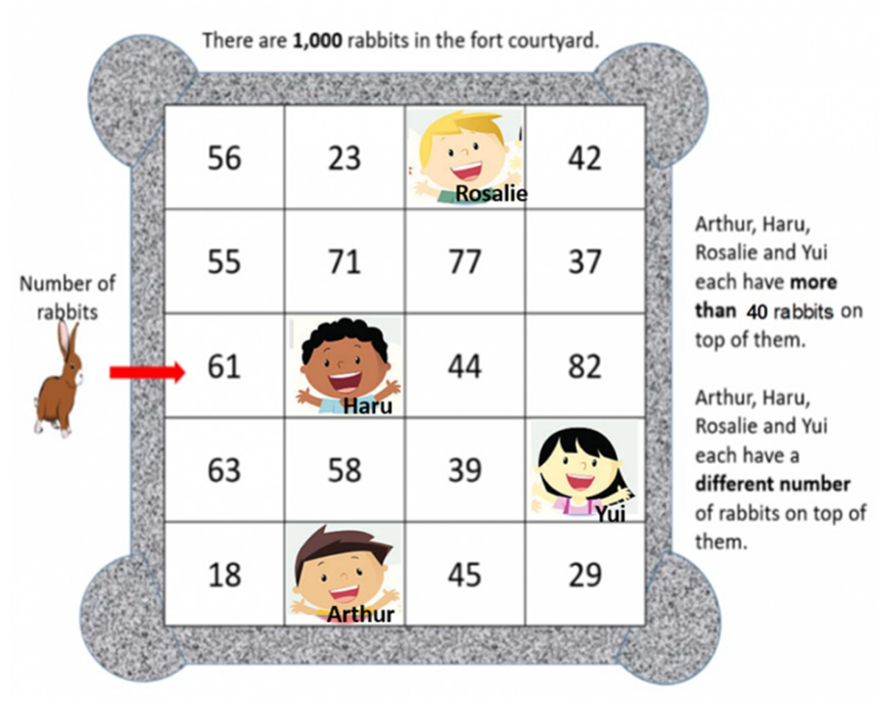 On Rabbit Island, 4 tourists entered a courtyard to feed the rabbits that lived there. Shortly afterwards, each tourist had more than 40 rabbits sitting on top of them!

You’ll notice that the courtyard is divided into smaller squares. Each square shows the number of rabbits within it. Altogether, there are **1,000**rabbits inside the courtyard and each square has a different number of rabbits.

**Can you work out how many rabbits there could be on top of each tourist?**

**Recording: (Use this space to show your working out and solution.)**