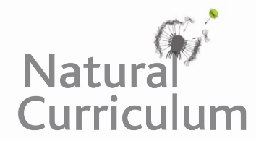
🗣️ If Planet Earth had a voice, what would it say to the human race? Prepare a short emotive speech that includes the following:
- The harm that is being done to you (e.g. climate change, deforestation and pollution)
- Your ability to recover when humans act with kindness and care towards you (e.g. planting seeds, recycling and litter picking)

Example:
Dear Humans,
I’ve watched you grow, build and explore. I’ve given you forests to breathe, rivers to drink and skies full of life. But lately, I’ve been hurting. My oceans are choked with plastic, my air heavy with smoke and my creatures are disappearing.
Yet I still believe in you. I’ve seen your kindness, your creativity, your power to change. If you choose to protect me, to live more gently, I can heal - and together, we’ll thrive. But I can’t wait forever. I need your help now. The choice is yours.
With hope, Planet Earth

